Prime Factors and Factor Trees

Write each of these numbers as a product of its prime factors:
(a) 6 (b) 8 (c) 15
(d) 12 (e) 14 (d) 20

Complete these factor trees:
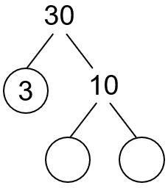
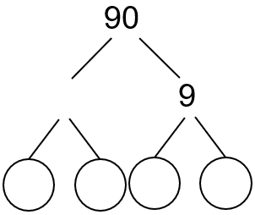
(a) (b)

By drawing a factor tree, write each of these numbers as a product of its prime factors:
(a) 56 (b) 60
(c) 75 (d) 78
(e) 80 (f) 115

As a product of its primes, what number is given by:
(a) $2×5×11$
(b) $3×3×5$
(c) $2×5×7$
(d) $2×2×3×3×5$

For each of these numbers, draw a factor tree and write as a product of its prime factors.
(a) 9 (b) 25 (c) 36
What do you notice?

As a product of its prime factors, $120=2×2×2×3×5$. How could you use this information to find all the factors of 120?
Prime Factors and Factor Trees

Write each of these numbers as a product of its prime factors:
(a) 6 (b) 8 (c) 15
(d) 12 (e) 14 (d) 20

Complete these factor trees:
(a) (b)

By drawing a factor tree, write each of these numbers as a product of its prime factors:
(a) 56 (b) 60
(c) 75 (d) 78
(e) 80 (f) 115

As a product of its primes, what number is given by:
(a) $2×5×11$
(b) $3×3×5$
(c) $2×5×7$
(d) $2×2×3×3×5$

For each of these numbers, draw a factor tree and write as a product of its prime factors.
(a) 9 (b) 25 (c) 36
What do you notice?

As a product of its prime factors, $120=2×2×2×3×5$. How could you use this information to find all the factors of 120?

