Representing Statistical Data Revision
(a) |  | (b) | (c)
The length in mm of 80 leaves is recorded in a grouped frequency table.  Length $L$ (mm) Frequency  $$20<L≤30$$ 4  $$30<L≤40$$ 7  $$40<L≤50$$ 15  $$50<L≤60$$ 23  $$60<L≤70$$ 22  $$70<L≤80$$ 9 | Complete a cumulative frequency table.  Length $L$ (mm) Cumulative Frequency  $$20<L≤30$$  $$20<L≤40$$  $$20<L≤50$$  $$20<L≤60$$  $$20<L≤70$$  $$20<L≤80$$ | Plot a cumulative frequency graph.  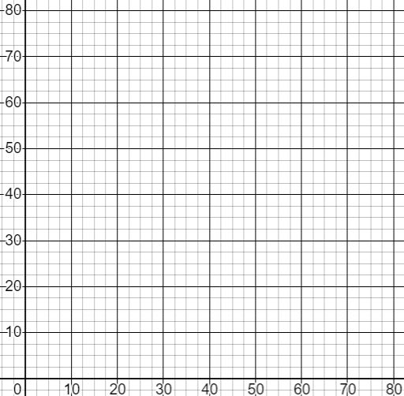 | (i) Find the median length.  (ii) Find the interquartile range of lengths.  (iii) Find an estimate for the number of leaves greater than 75 mm in length.
(a) |  | (b) | (c)
The areas in $m^{2}$of 200 gardens are recorded in a grouped frequency table. Calculate the frequency density.  Area $(m^{2})$ Frequency  $$0<A≤50$$ 10  $$50<A≤100$$ 25  $$100<A≤200$$ 80  $$200<A≤300$$ 65  $$300<A≤500$$ 20 |  | Plot a histogram.  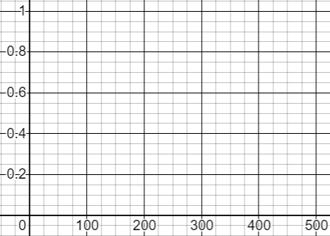 | (i) Use your histogram to estimate the number of gardens that are larger than ${220 m}^{2}$.  (ii) Use your histogram to estimate the median garden size.

