Fill in the Blanks | Plotting Straight Line Graphs

Equation | $$y=x+3$$ | $$y=x+1$$ | $$y=2x$$ | $$y=8-x$$
Table | $$x$$ $$0$$ $$1$$ $$2$$ $$3$$  $$y$$ $$3$$ $$4$$ $$5$$ | $$x$$ $$0$$ $$1$$ $$2$$ $$3$$  $$y$$ $$1$$ $$4$$ | $$x$$ $$0$$ $$1$$ $$2$$ $$3$$  $$y$$ $$4$$ $$6$$ | $$x$$ $$0$$ $$1$$ $$2$$ $$3$$  $$y$$ $$5$$
Graph | 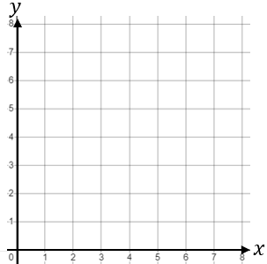

Equation | $$y=2x+1$$ | $$y=x-1$$ | $$y=2-x$$ | $$y=0.5x+3$$
Table | $$x$$ $$-2$$ $$-1$$ $$0$$ $$1$$  $$y$$ $$-3$$ $$-1$$ | $$x$$ $$-2$$ $$-1$$ $$0$$ $$1$$  $$y$$ $$-1$$ | $$x$$ $$-2$$ $$-1$$ $$0$$ $$1$$  $$y$$ $$2$$ | $$x$$ $$-2$$ $$-1$$ $$0$$ $$1$$  $$y$$ $$3.5$$
Graph | 