Line Symmetry

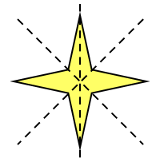
Add the missing line of symmetry to each of these shapes.
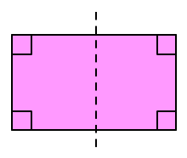
(a) (b)

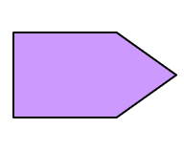
Draw all the lines of symmetry on each of these shapes.
(a) (b)

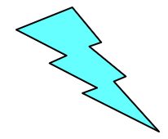
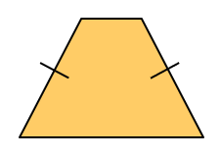
(c) (d)

Draw all the lines of symmetry on each of these regular polygons.
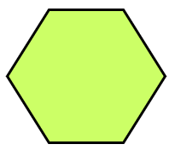
(a) (b)

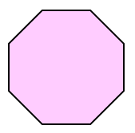
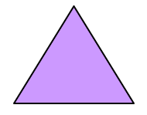
(c) (d)

Add one square to each of these shapes so that they have the lines of symmetry shown.
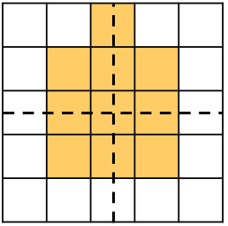
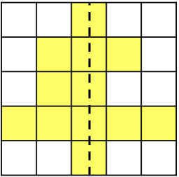
(a) (b)

Line Symmetry

Add the missing line of symmetry to each of these shapes.
(a) (b)

Draw all the lines of symmetry on each of these shapes.
(a) (b)

(c) (d)

Draw all the lines of symmetry on each of these regular polygons.
(a) (b)

(c) (d)

Add one square to each of these shapes so that they have the lines of symmetry shown.
(a) (b)

