Circle Theorems and Quadrilaterals
(a) | (b) | (c)
Find the missing angle $a$.  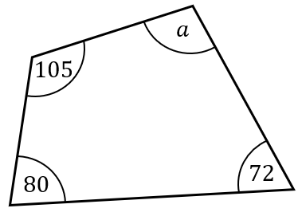 | Find the missing angles $b$ and $c$.  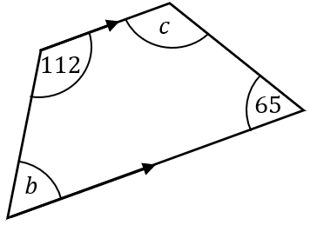 | Find the missing angle $d$.  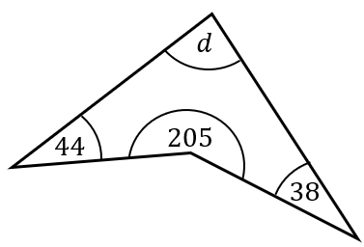
(d) | (e) | (f)
What is the relationship between angles $e$ and $f$?  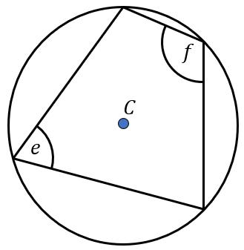 | What is the relationship between angles $g$ and $h$?  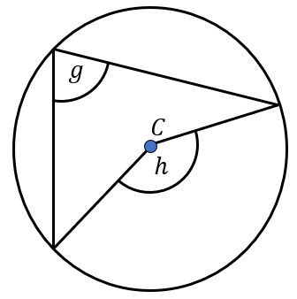 | Find the value of $j$.  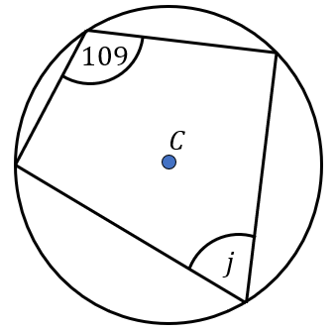
(g) | (h) | (i)
Find the value of $k$.  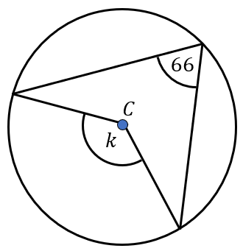 | Find the values of $m$ and $n$.  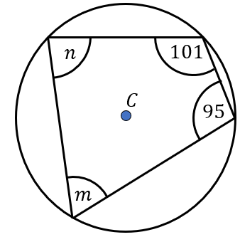 | Find the value of $p$.  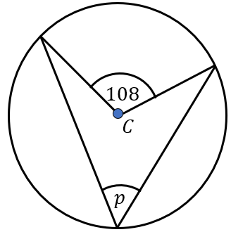
(j) | (k) | (l)
Find the values of $q$ and $r$.  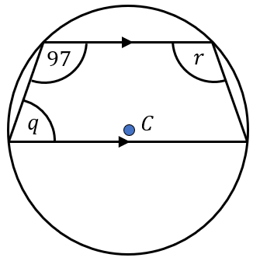 | Find the values of $s$ and $t$.  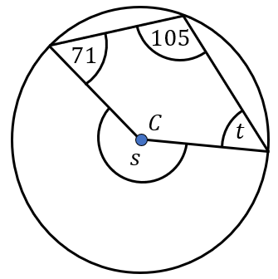 | Find the values of $u$ and $v$.  