Algebraic Problems involving Sine and Cosine Rules
(a) | (b) | (c)
Find the value of $x$  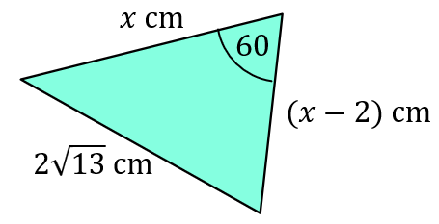 | Find the value of $x$  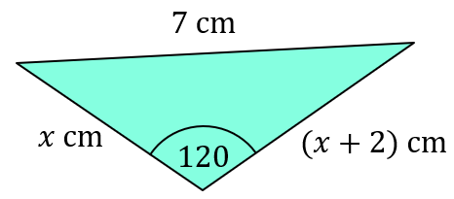 | Find the value of $x$  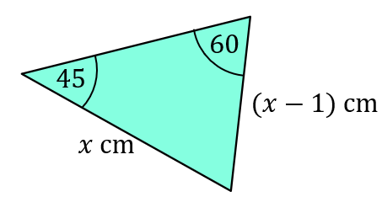
(d) | (e) | (f)
Find the value of $x$  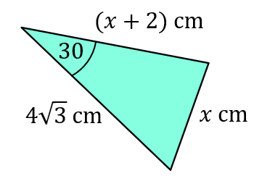 | Find the value of $x$  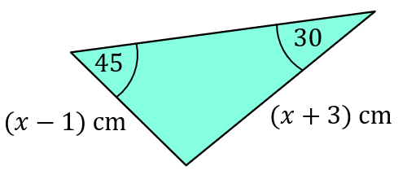 | Find the value of $x$  