Fill in the Blanks | Evaluating Composite One-Step Functions

Question | Input | 1st Function | 2nd Function | Output | Answer
$$f\left(x\right)=3x g\left(x\right)=x-1$$  Find $fg(2)$ | 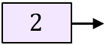 | 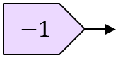 | 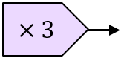 | 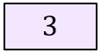 | $$fg\left(2\right)=$$
$$f\left(x\right)=5x g\left(x\right)=x+3$$  Find $gf(6)$ | 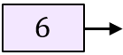 | 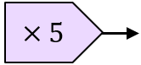 | 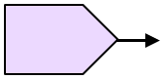
$$f\left(x\right)=x-1 g\left(x\right)=x^{2}$$
Find $fg(3)$
$$f\left(x\right)=x+9 g\left(x\right)=\sqrt{x}$$
Find $gf(-5)$
$$f\left(x\right)=\frac{x}{2} g\left(x\right)=x+7$$
Find $fg(4)$
$$g\left(x\right)=\sqrt{x} h\left(x\right)=x-3$$
Find $gh(3.25)$
$$f\left(x\right)=\frac{1}{x} g\left(x\right)=x^{2}$$
Find $gf(0.4)$

