Fill in the Blanks | Evaluating Two-Step Functions

Question | Input | Function Machine |  | Output
$$f\left(x\right)=2x-1$$  Find $f(5)$ | 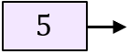 | 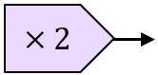 | 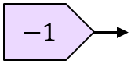
$$f\left(x\right)=4x+3$$  Find $f(-3)$ |  | 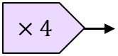 | 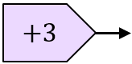
$$f\left(x\right)=x^{2}-5$$  Find $f(4)$ |  | 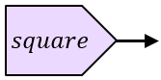 | 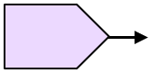
$$g\left(x\right)=\frac{x+3}{2}$$  Find $g(11)$ |  |  | 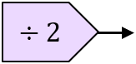
$$f\left(x\right)=\sqrt{x+5}$$
Find $f(4)$
$$f\left(x\right)=\frac{x}{2}+1$$
Find $f(2.5)$
$$f\left(x\right)=3(x+2)$$
Find $f(-7)$
$$h\left(x\right)={(x+3)}^{2}$$
Find $h(-5)$
$$f\left(x\right)=4x^{2}$$
Find $f(\sqrt{3})$
$$f\left(x\right)=\frac{1}{x}+9$$
Find $f(2)$
$f\left(x\right)=$  Find | 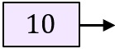 |  | 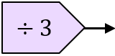
$f\left(x\right)=$  Find | 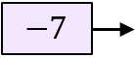 | 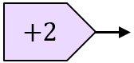 | 