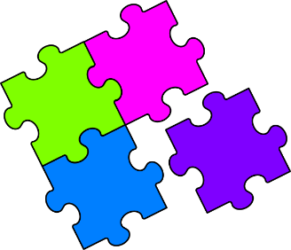Match-Up

**Trigonometric Equations**

Match the trigonometric equation with the correct diagram.

|  |  |  |  |  |  |  |
| --- | --- | --- | --- | --- | --- | --- |
| **1** |  | **2** |  |  | **A** | $$x=\tan^{-1}\left(\frac{7}{10}\right)$$ |
|  | **B** | $$x=10×\sin{38}$$ |
| **3** |  | **4** |  |  | **C** | $$x=10×\tan{38}$$ |
|  | **D** | $$x=\frac{10}{\sin{38}}$$ |
| **5** |  | **6** |  |  | **E** | $$x=\sin^{-1}\left(\frac{7}{10}\right)$$ |
|  | **F** | $$x=\tan^{-1}\left(\frac{10}{7}\right)$$ |
| **7** |  | **8** |  |  | **G** | $$x=10×\cos{38}$$ |
|  | **H** | $$x=\frac{10}{\cos{38}}$$ |
| **9** |  | **10** |  |  | **I** | $$x=\frac{10}{\tan{38}}$$ |
|  | **J** |  |

|  |  |  |  |  |  |  |  |  |  |
| --- | --- | --- | --- | --- | --- | --- | --- | --- | --- |
| **1** | **2** | **3** | **4** | **5** | **6** | **7** | **8** | **9** | **10** |
|  |  |  |  |  |  |  |  |  |  |