Fill in the Blanks | Matrix Multiplication

Question |  |  | Working |  | Answer
$$\left(\begin{matrix}3 & 0 \\ 1 & 4\end{matrix}\right)$$ | $$×$$ | $$\left(\begin{matrix}2 & 1 \\ 5 & 0\end{matrix}\right)$$ | $$3×2+0×5$$ | $$3×1+0×0$$ | 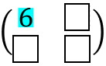
 |  |  | $$1×2+4×5$$ | $$1×1+4×0$$
$$\left(\begin{matrix}4 & 2 \\ 3 & 0\end{matrix}\right)$$ | $$×$$ | $$\left(\begin{matrix}7 & 0 \\ 1 & 1\end{matrix}\right)$$ |  | $$4×0+2×1$$ | 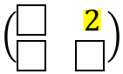
 |  |  | $$3×7+0×1$$ | $$3×0+0×1$$
$$\left(\begin{matrix}2 & -1 \\ 1 & 3\end{matrix}\right)$$ | $$×$$ | $$\left(\begin{matrix}0 & 4 \\ 2 & 1\end{matrix}\right)$$ |  |  | 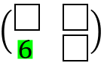
 |  |  | $$1×0+3×2$$
$$\left(\begin{matrix}-3 & 1 \\ -2 & 0\end{matrix}\right)$$ | $$×$$ | $$\left(\begin{matrix}0 & -1 \\ 4 & 1\end{matrix}\right)$$ |  |  | 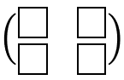
$$\left(\begin{matrix}1.5 & 0 \\ -3 & 2\end{matrix}\right)$$ | $$×$$ | $$\left(\begin{matrix}4 & 0.5 \\ 2 & -1\end{matrix}\right)$$
$$\left(\begin{matrix}\frac{3}{4} & -2 \\ 0 & 3\end{matrix}\right)$$ | $$×$$ | $$\left(\begin{matrix}-1 & \frac{2}{3} \\ 4 & 2\end{matrix}\right)$$
$$\left(\begin{matrix}1 & \sqrt{3} \\ -2 & 0\end{matrix}\right)$$ | $$×$$ | $$\left(\begin{matrix}-2 & 0 \\ \sqrt{3} & 4\end{matrix}\right)$$
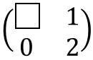 | $$×$$ | 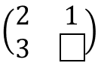 |  |  | 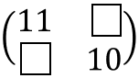
 | $$×$$ | $$\left(\begin{matrix}2 & -1 \\ 1 & 3\end{matrix}\right)$$ |  |  | $$\left(\begin{matrix}3 & 16 \\ 7 & 0\end{matrix}\right)$$

