Angles in Irregular Polygons

Find the missing exterior angles.
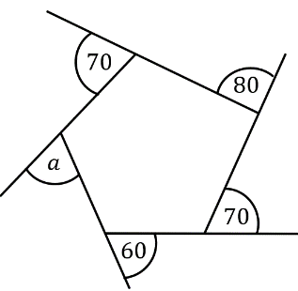
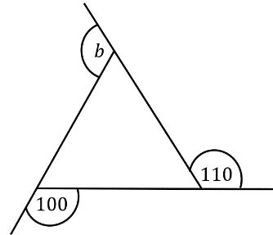
(a) (b)

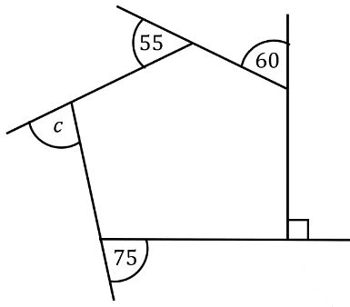
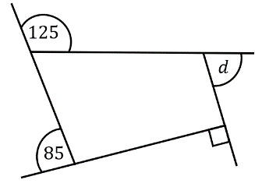
(c) (d)

(a) An irregular quadrilateral has interior angles of $90°$, $100°$ and $105°$. What is the size of the fourth angle?
(b) An irregular hexagon has angles of $100°$, $110°$, $115°$, $130°$, and $140°$. What is the size of the sixth angle?
(c) An irregular octagon has six angles of $145°$. If the remaining two angles are equal, what is the size of each?

Jay measured the exterior angles in this polygon. Explain how you know his measurements are wrong.
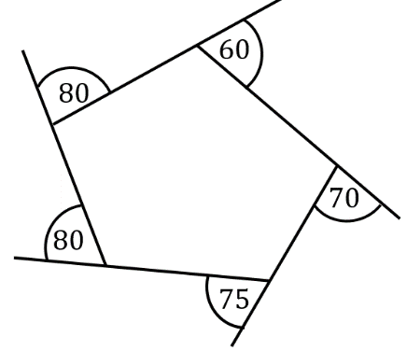

A decagon has 2 angles of the same size and a further 8 angles of twice the size. What are the sizes of the angles?
Angles in Irregular Polygons

Find the missing exterior angles.
(a) (b)

(c) (d)

(a) An irregular quadrilateral has interior angles of $90°$, $100°$ and $105°$. What is the size of the fourth angle?
(b) An irregular hexagon has angles of $100°$, $110°$, $115°$, $130°$, and $140°$. What is the size of the sixth angle?
(c) An irregular octagon has six angles of $145°$. If the remaining two angles are equal, what is the size of each?

Jay measured the exterior angles in this polygon. Explain how you know his measurements are wrong.

A decagon has 2 angles of the same size and a further 8 angles of twice the size. What are the sizes of the angles?

