Estimating the Gradient of a Curve
(a) | (b)
Estimate the gradient of the curve at  (a) $x=2$  (b) $x=-1$ | Estimate the gradient of the curve at  (a) $x=-1.5$  (b) $x=1$
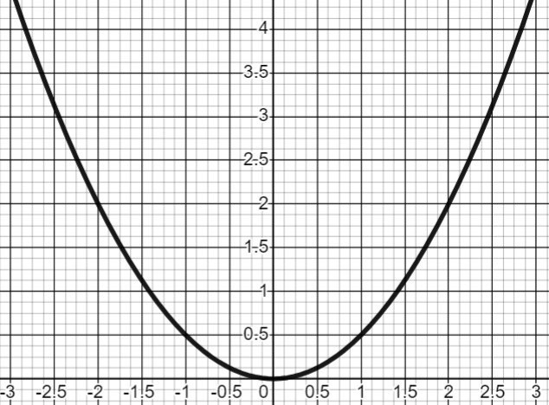 | 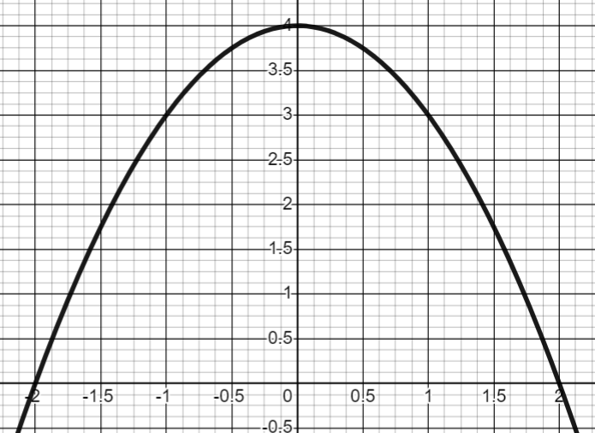

(c) | (d)
Estimate the gradient of the curve at  (a) $x=2$  (b) $x=4$ | Estimate the gradient of the curve at  (a) $x=2$  (b) $x=-1$
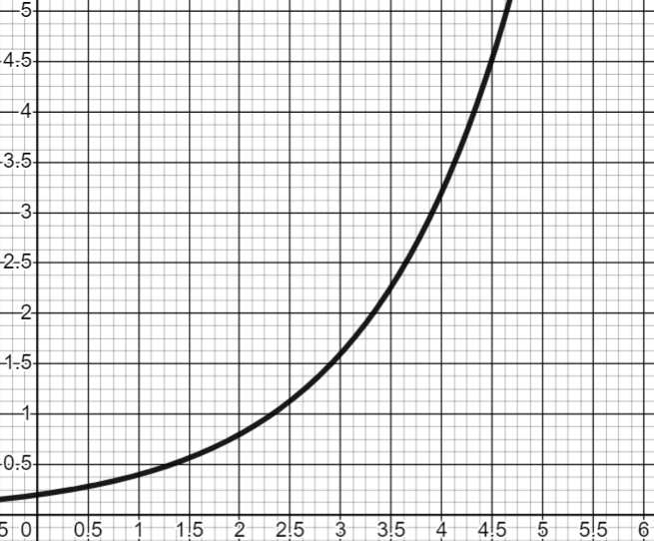 | 