Interpreting Histograms
(a) | (b) | (c)
The histogram shows some information about the lengths of some sycamore leaves. | The histogram shows some information about the waiting times in a queue at a supermarket. | The histogram shows some information about the ages of people visiting a library.  Ten of the people who visited the library were less than 20 years old.
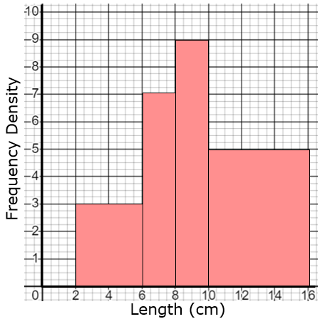 | 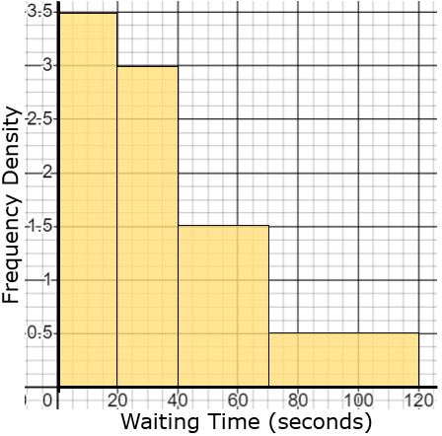 | 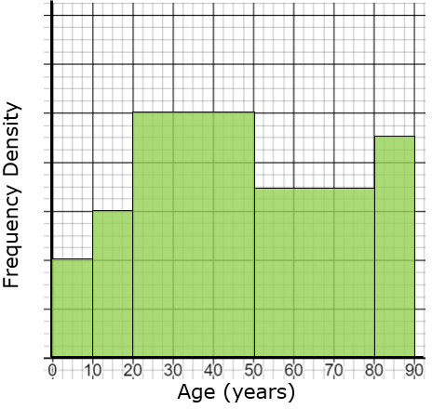
(a) Find the total number of leaves that were measured. | (a) Find an estimate of the proportion of customers who waited more than 50 seconds. | (a) Find the number of people visiting the library who are over 50 years old.
(b) Find an estimate of the number of leaves that were less than 7 cm in length. | (b) Find an estimate of the median waiting time. | (b) Find an estimate of the median age of the people visiting the library.

