Plotting Histograms
(a) | (b) | (c)
Plot a histogram from the data shown in the table.  Height (cm) Frequency Frequency Density  $$0<h≤20$$ $$24$$ $$1.2$$  $$20<h≤40$$ $$32$$ $$1.6$$  $$40<h≤80$$ $$44$$  $$80<h≤90$$ $$14$$ | Plot a histogram from the data shown in the table.  Speed (mph) Frequency Frequency Density  $$0<s≤10$$ $$5$$  $$10<s≤35$$ $$30$$  $$35<s≤50$$ $$24$$  $$50<s≤70$$ $$16$$ | Plot a histogram from the data shown in the table.  Time (hours) Frequency Frequency Density  $$0<h≤4$$ $$3$$  $$4<h≤8$$ $$5$$  $$8<h≤16$$ $$22$$  $$16<h≤22$$ $$15$$  $$22<h≤25$$ $$6$$
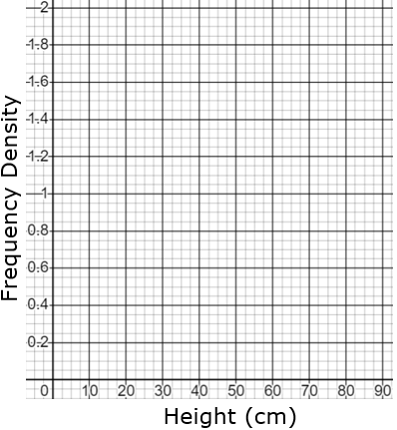 | 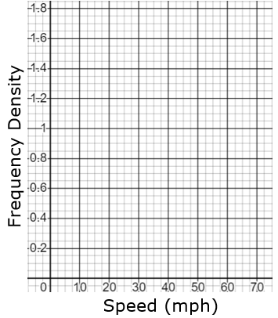 | 