Area of a Sector
(a) | (b) | (c) | (d) |  | (e)
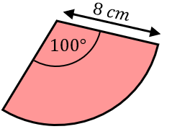  Find the area. | 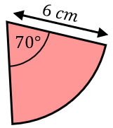  Find the area. | 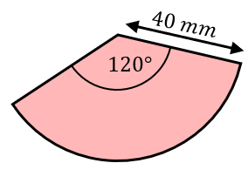  Find the area. | 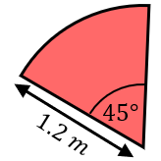  Find the area. |  | 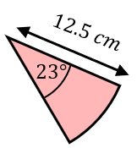  Find the area.
(f) | (g) | (h) | (i) |  | (j)
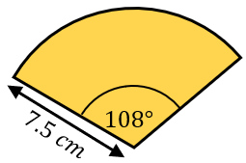  Find the area. | 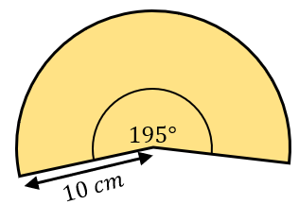  Find the area. | 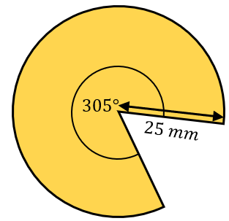  Find the area. | 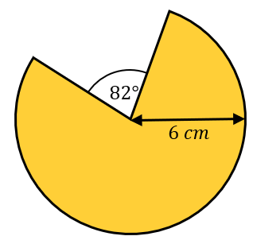  Find the area. |  | 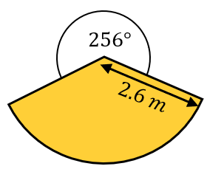  Find the area.
(k) | (l) | (m) |  | (n)
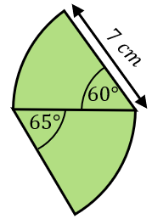  Find the area. | Find the area.  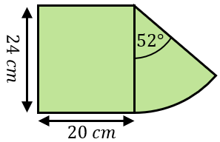 | 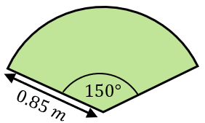  Tia wants a fan-shaped mirror, as shown in the diagram. Mirrored glass costs £82.50 per $m^{2}.$ How much will Tia’s mirror cost to make? |  | Pablo has a sector-shaped swimming pool with dimensions shown. He wants to fill his pool to a depth of 1.8 m. How many litres of water will he need?  