Algebra Revision |  |  |  | 2
(a) | (b) | (c) | (d)
Simplify $2a^{2}b^{3}c×5ab^{2}c^{2}$ | Find the nth term of the sequence :  $$1, 7, 13, 19,…$$ | Make $x$ the subject of  $y=ax+b$ | (i) Write down the coordinates of point $A$  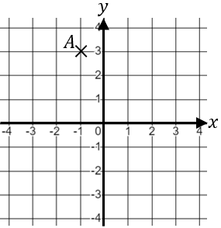  (ii) Plot the point $(3, -2)$on the grid above.
(e) | (f) | (g)
Solve  $$5x-3=x+12$$ | Expand and simplify  $$5\left(x+2\right)-2(x-3)$$ | Solve  $$3y+11≥2$$
(h) | (i) | (j) | (k)
$$-9<3x≤15$$  Write down all the possible integer values of $x$. | Factorise fully  $10{xy}^{2}+25x^{2}y$ | Expand and simplify  $$(x+5)(x-2)$$ | Find the equation of the straight line shown.  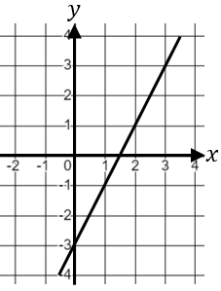
(l) | (m) | (n)
Solve $7\left(x+3\right)=x-3$ | Write down the gradient of the straight line with equation  $$y=-5x+4$$ | Solve $x+5=\frac{2x-3}{4}$

