Function Machines

Here is a function machine.
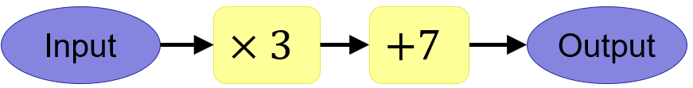
(a) Find the output when the input is 10
(b) Find the output when the input is 2.5
(c) Find the output when the input is -3
(d) Find the input when the output is 31

Here is a function machine.
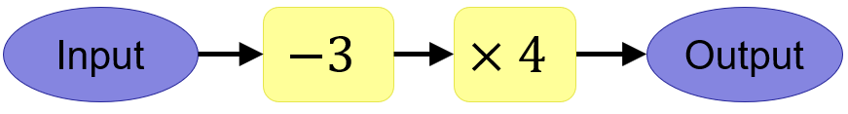
(a) Find the output when the input is 5
(b) Find the output when the input is 12
(c) Find the output when the input is 2
(d) Find the input when the output is 28

Here is a function machine.
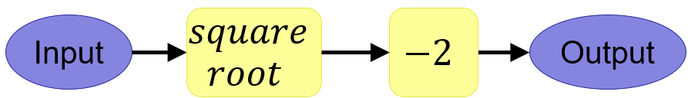
(a) Find the output when the input is 25
(b) Find the output when the input is 49
(c) Find the output when the input is 121
(d) Find the input when the output is 2

Here is a function machine.
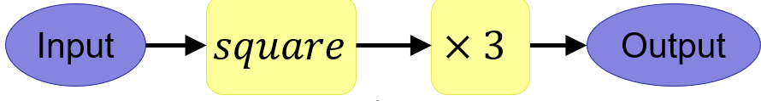
(a) Find the output when the input is 2
(b) Find the output when the input is 10
(c) Find the output when the input is -5
(d) Find the input when the output is 48

(a) When the input is 3, the output is 10. Suggest two possible function machines.
(b) When I input 2, I get an output of 7. When I input 4, I get an output of 17. Can you work out what my two-step function machine is?

Function Machines

Here is a function machine.
(a) Find the output when the input is 10
(b) Find the output when the input is 2.5
(c) Find the output when the input is -3
(d) Find the input when the output is 31

Here is a function machine.
(a) Find the output when the input is 5
(b) Find the output when the input is 12
(c) Find the output when the input is 2
(d) Find the input when the output is 28

Here is a function machine.
(a) Find the output when the input is 25
(b) Find the output when the input is 49
(c) Find the output when the input is 121
(d) Find the input when the output is 2

Here is a function machine.
(a) Find the output when the input is 2
(b) Find the output when the input is 10
(c) Find the output when the input is -5
(d) Find the input when the output is 48

(a) When the input is 3, the output is 10. Suggest two possible function machines.
(b) When I input 2, I get an output of 7. When I input 4, I get an output of 17. Can you work out what my two-step function machine is?

