Rotations Using Matrices
(a) | (b) | (c)
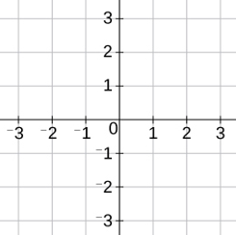  By considering the unit square, determine the matrix which describes a rotation $90°$ clockwise about the origin. | Describe fully the single transformation represented by the matrix $\left(\begin{matrix}0 & -1 \\ 1 & 0\end{matrix}\right)$ | By considering the unit square, determine the matrix which describes a rotation $180°$ about the origin.
(d) | (e) | (f)
The point $(1, -6)$ is mapped onto the point $(a, b)$ when rotated $90°$ anti-clockwise about the origin. Using matrix algebra, find the values of $a$ and $b$. | The point $(c, d)$ is mapped onto the point $(2, 4)$ when rotated $270°$ anti-clockwise about the origin. Using matrix algebra, find the values of $c$ and $d$. | A triangle with vertices at $(1, 1)$, $(5, 2)$ and $(4, -1)$ is rotated $180°$ about the origin. Use matrix algebra to find the coordinates of the vertices of the rotated triangle.
(g) | (h) | (i)
Use matrix algebra to show that a rotation of $90°$ clockwise about the origin, followed by a rotation of $180°$ is equivalent to a rotation of $90°$ anti-clockwise about the origin. | The point $(a, 6)$ is mapped onto the point $(b, -4)$ following a rotation of $90°$ anti-clockwise about the origin. Use matrix algebra to find the values of $a$ and $b$. | The point $(x, 2y+6)$ is mapped onto the point $(2x, y-7)$ following a rotation of $90°$ clockwise about $(0, 0)$ . Use matrix algebra to find the values of $x$ and $y$.

