Evaluating Functions from Graphs

The graph shows the function $f(x)$.
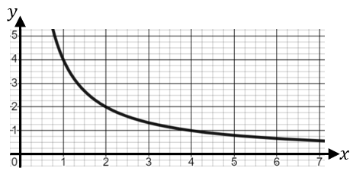
Use the graph to evaluate:
(a) $f(1)$ (b) $f(4)$
(c) $f(2)$ (d) $f(5)$

The graph shows the function $g(x)$.
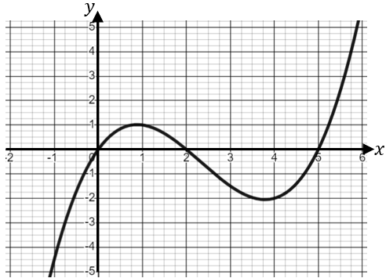
Use the graph to evaluate:
(a) $g(1)$ (b) $g(4)$
(c) $g(5)$ (d) $g(-1)$

The graph shows the function $h(x)$.
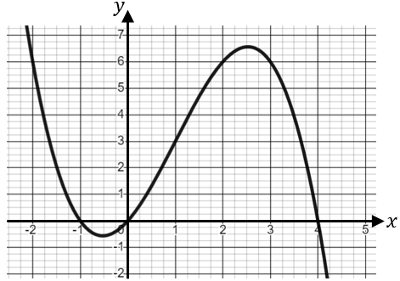
Use the graph to evaluate:
(a) $h(1)$ (b) $h(-1)$
(c) $h(3)$ (d) $h(2.5)$
Evaluating Functions from Graphs

The graph shows the function $f(x)$.
Use the graph to evaluate:
(a) $f(1)$ (b) $f(4)$
(c) $f(2)$ (d) $f(5)$

The graph shows the function $g(x)$.
Use the graph to evaluate:
(a) $g(1)$ (b) $g(4)$
(c) $g(5)$ (d) $g(-1)$

The graph shows the function $h(x)$.
Use the graph to evaluate:
(a) $h(1)$ (b) $h(-1)$
(c) $h(3)$ (d) $h(2.5)$

