Match-Up | Representing Inequalities

1 | 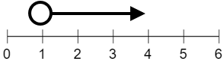 |  | 6 | 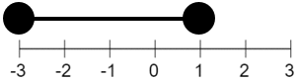 |  | 11 | 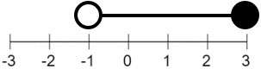
2 | 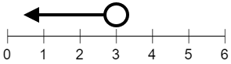 |  | 7 | 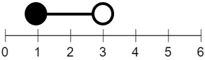 |  | 12 | 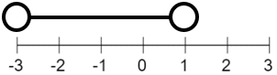
3 | 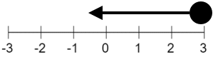 |  | 8 | 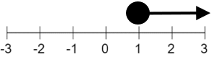 |  | 13 | 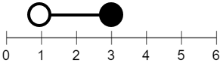
4 | 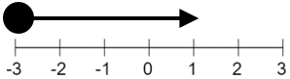 |  | 9 | 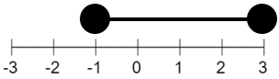 |  | 14 | 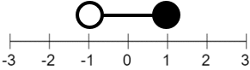
5 | 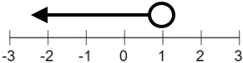 |  | 10 | 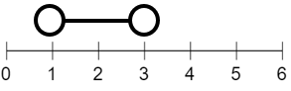 |  | 15 | 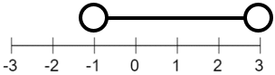
A | $$-3<x<1$$ |  | F | $$1<x<3$$ |  | K | $$-1<x<3$$
B | $$-1≤x≤3$$ |  | G | $$x≥1$$ |  | L | $$-3≤x≤1$$
C | $$x<3$$ |  | H | $$-1<x≤3$$ |  | M | $$x≤3$$
D | $$1≤x<3$$ |  | I | $$x>1$$ |  | N | $$-1<x≤1$$
E | $$x<1$$ |  | J | $$1<x≤3$$ |  | P | $$x≥-3$$

1 | 2 | 3 | 4 | 5 | 6 | 7 | 8 | 9 | 10 | 11 | 12 | 13 | 14 | 15

