Solving Quadratic Equations Which Require Rearrangement

Solve by factorisation:
(a) $x^{2}+4x=5$
(b) $12=x^{2}-4x$
(c) $x=x^{2}-20$
(d) $x^{2}=6x-8$
(e) $9x=22-x^{2}$

Solve by factorisation:
(a) $x^{2}+4x=2x+15$
(b) $11+x^{2}+3x=5-2x$
(c) $7-4x=x^{2}-10x$
(d) ${2x}^{2}+30=x^{2}+13x$
(e) $4+5x-x^{2}=34-6x$

Solve by factorisation:
(a) $x\left(x-5\right)=14$
(b) $25+x=x(x+1)$
(c) $3\left(x+4\right)=x^{2}+2x$
(d) $x\left(x-1\right)=5\left(x+2\right)+6$
(e) $\left(x+2\right)\left(x-3\right)=5x+21$

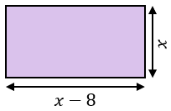
(a) Given that the area of the rectangle is $65 {cm}^{2}$, form a quadratic equation and solve it to find $x$.

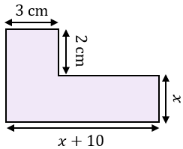
(b) Given that the area of the compound shape is $45 {cm}^{2}$, form a quadratic equation and solve it to find $x$.

Solving Quadratic Equations Which Require Rearrangement

Solve by factorisation:
(a) $x^{2}+4x=5$
(b) $12=x^{2}-4x$
(c) $x=x^{2}-20$
(d) $x^{2}=6x-8$
(e) $9x=22-x^{2}$

Solve by factorisation:
(a) $x^{2}+4x=2x+15$
(b) $11+x^{2}+3x=5-2x$
(c) $7-4x=x^{2}-10x$
(d) ${2x}^{2}+30=x^{2}+13x$
(e) $4+5x-x^{2}=34-6x$

Solve by factorisation:
(a) $x\left(x-5\right)=14$
(b) $25+x=x(x+1)$
(c) $3\left(x+4\right)=x^{2}+2x$
(d) $x\left(x-1\right)=5\left(x+2\right)+6$
(e) $\left(x+2\right)\left(x-3\right)=5x+21$

(a) Given that the area of the rectangle is $65 {cm}^{2}$, form a quadratic equation and solve it to find $x$.

(b) Given that the area of the compound shape is $45 {cm}^{2}$, form a quadratic equation and solve it to find $x$.

