Finding the Equation of Exponential Graphs
(a) | (b) | (c)
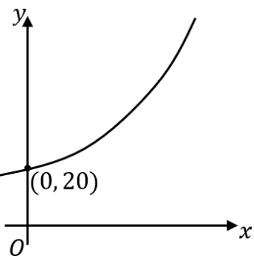  The curve has equation $y=ab^{x}$. Write down the value of $a$. | 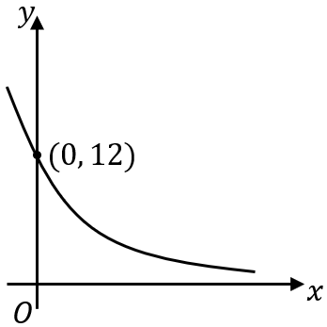  The curve has equation $y=ab^{-x}$. Write down the value of $a$. | 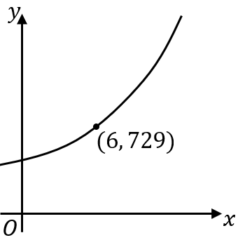  The curve has equation $y=k^{x}$. Find the value of $k.$
(d) | (e) | (f)
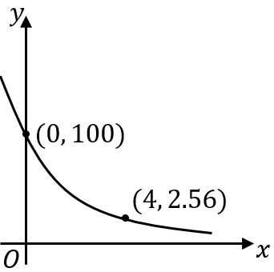  The curve has equation $y=ab^{-x}$. Find the values of $a$ and $b$, where $b>0$ | 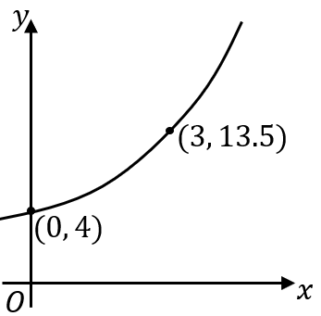  The curve has equation $y=ab^{x}$. Find the values of $a$ and $b.$ | 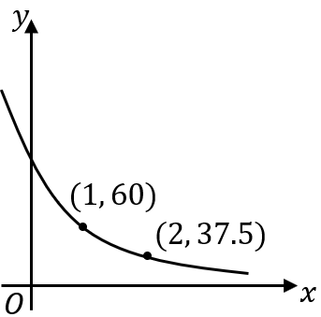  The curve has equation $y=ab^{-x}$. Find the values of $a$ and $b.$
(g) | (h) | (i)
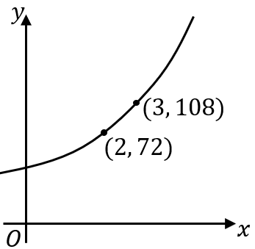  The curve has equation $y=ab^{x}$. Find the values of $a$ and $b.$ | 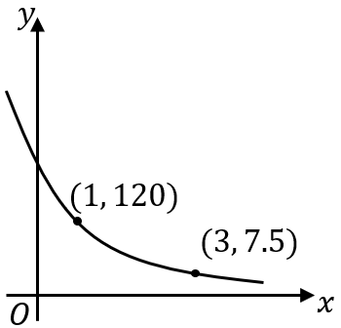  The curve has equation $y=ab^{-x}$. Find the values of $a$ and $b$, where $b>0$ | 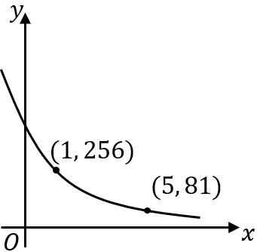  The curve has equation $y=ab^{-x}$. Find the values of $a$ and $b$, where $b>0$

