Quadratics Revision
(a) | (b) |  | (c)
Find the coordinates of the turning point of the curve with equation  $$y=2x^{2}+7x-3$$ | Solve  $$5y=4-\sqrt{y}$$ |  | Find the equation of the quadratic curve.  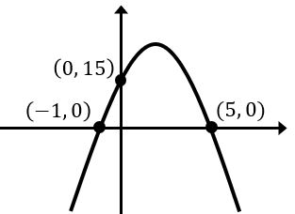
(d) | (e) |  | (f)
Given that the line $y=2x-5$ intersects the curve $y=3x^{2}+ax-1$ at two points, find the possible range of values for $a$. | Find the set of values for which  $5-2x≥3x+1$ and $8x^{2}<3+10x.$  Give your answer in set notation. |  | Solve the simultaneous equations  $$x-y=8$$  $$2x-y^{2}-1=0$$
(g) |  | (h)
A quadratic curve and a line form a region shaded on the graph shown. Find the single inequality which describes the region.  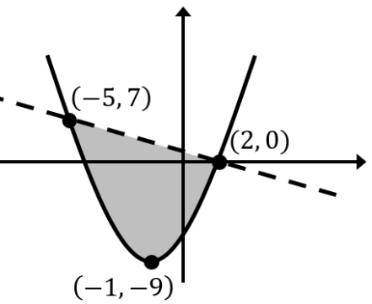 |  | The path of a tennis ball through the air can be modelled as a curve with equation $h=0.608+0.72x-0.05x^{2}$ where $h$ is the height of the ball and $x$ is the horizontal distance from the tennis player.  (a) Find the height of the ball when it has travelled $2 m$ horizontally.  (b) Find the horizontal distance of the ball from the tennis player  when it hits the ground.  (c ) Find the maximum height of the tennis ball.

