Match-Up | Volume of Cubes and Cuboids

1 | Find the volume of the cube.  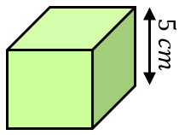 | 5 | The volume is $420 {cm}^{3}.$Find $x$.  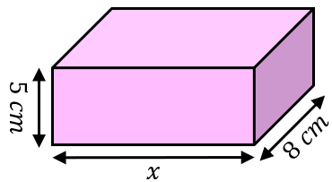 | 9 | A cuboid with dimensions $12 cm$ by $24 cm$ by $40 cm$ is filled by $180$ identical cubes. What is the length of the side of a cube?
2 | Find the volume.  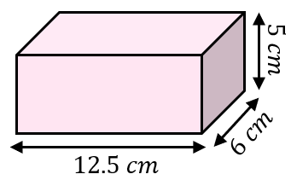 | 6 | The volume is $289 {cm}^{3}.$Find $x$.  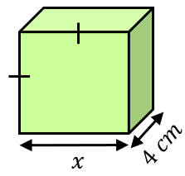 | 10 | The volume of a cube is twice the volume of a cuboid with dimensions $3 cm$ by$4 cm$ by $9 cm$. Find the side length of the cube.
3 | Find the volume.  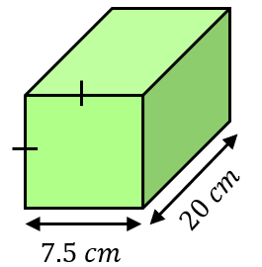 | 7 | Find the side length of a cube with volume $3375 {cm}^{3}$. | 11 | A cuboid has side lengths in the ratio  $2 : 4 : 5$. If the shortest side length is $5 cm$, find the volume of the cuboid.
4 | Find the volume.  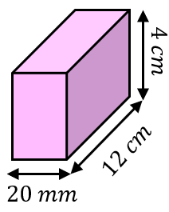 | 8 | Find the volume of a cuboid whose side lengths in $cm$ are the first, third and fifth prime numbers. | 12 | A cuboid has sides of length $x$, $x$ and $3x$. Its volume is $1536 {cm}^{3}$. Find the value of $x$.

A | $$15 cm$$ | D | $$8 cm$$ | G | $$10.5 cm$$ | J | $$4 cm$$
B | $$110 {cm}^{3}$$ | E | $$8.5 cm$$ | H | $$625 {cm}^{3}$$ | K | $$125 {cm}^{3}$$
C | $$6 cm$$ | F | $$375 {cm}^{3}$$ | I | $$96 {cm}^{3}$$ | L | $$1125 {cm}^{3}$$

1 | 2 | 3 | 4 | 5 | 6 | 7 | 8 | 9 | 10 | 11 | 12

