Volume and Surface Area of Frustums

Find the volume of each of these frustums.
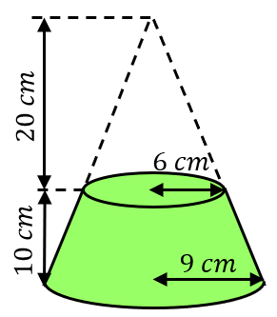
(a) (b)
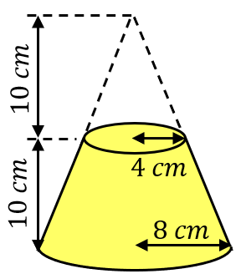

Find the volume of each of these frustums.
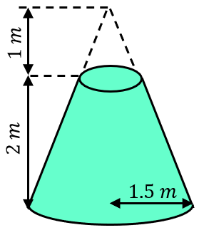
(a) (b)
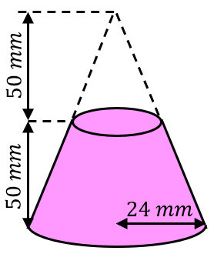

Find the curved surface area and total surface area of each of these frustums.
(a) (b)
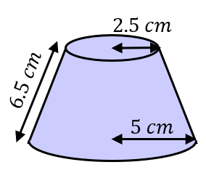
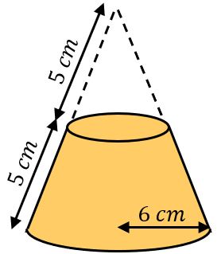

The base diameter of a frustum is $18 cm$ and the top diameter is $9 cm$. If the frustum has a volume of $378π {cm}^{3}$, find its height.
Volume and Surface Area of Frustums

Find the volume of each of these frustums.
(a) (b)

Find the volume of each of these frustums.
(a) (b)

Find the curved surface area and total surface area of each of these frustums.
(a) (b)

The base diameter of a frustum is $18 cm$ and the top diameter is $9 cm$. If the frustum has a volume of $378π {cm}^{3}$, find its height.

