Enlarging Shapes
(a) | (b) | (c)
Enlarge by scale factor $2$ about the point shown.  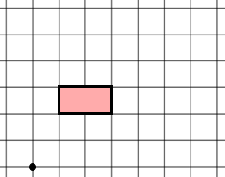 | Enlarge by scale factor $3$ about the point shown.  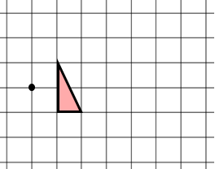 | Enlarge by scale factor $4$ about the point shown.  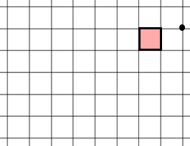
(d) | (e) | (f)
Enlarge the shape by scale factor $3$ about the origin.  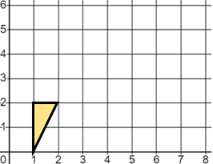 | Enlarge the shape by scale factor $1\frac{1}{2}$ about the origin.  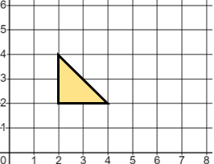 | Enlarge the shape by scale factor $2$, centre $(0, 3)$.  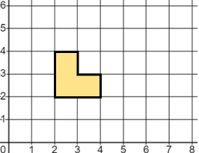
(g) | (h) | (i)
Enlarge the shape by scale factor $3$, centre $(1, 4)$.  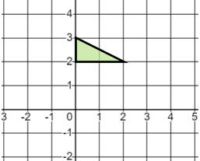 | Enlarge the shape by scale factor $4$, centre $(-1, -1)$.  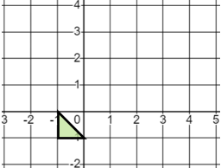 | Enlarge the shape by scale factor $2$, centre $(-3, 2)$.  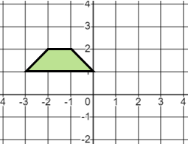
(j) | (k) | (l)
Enlarge the shape by scale factor $\frac{1}{2}$, centre $(1, 0)$.  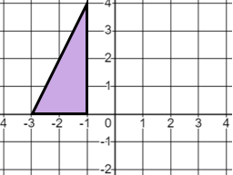 | Enlarge the shape by scale factor $\frac{1}{3}$, centre $(5, 4)$.  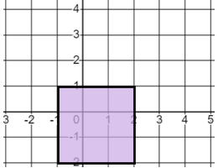 | Enlarge the shape by scale factor $\frac{1}{4}$, centre $(-2, 4)$.  