Volume of a Pyramid

Find the volume of each of these pyramids.
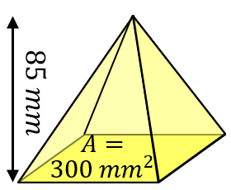
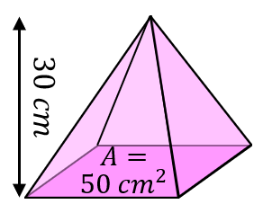
(a) (b)

Find the volume of each of these square-based pyramids.
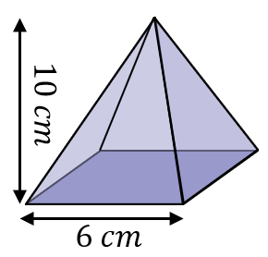
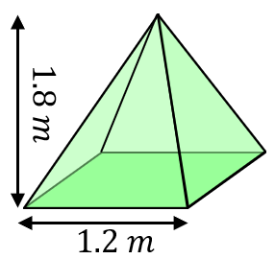
(a) (b)

Find the volumes of each of these pyramids.
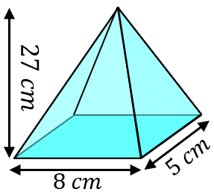
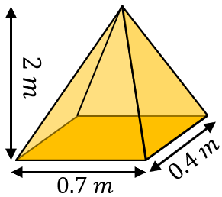
(a) (b)

Find the missing measurements from each of these pyramids when given their volumes.
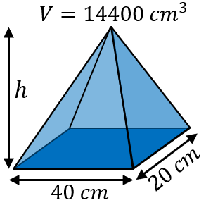
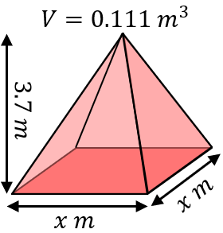
(a) (b)

Volume of a Pyramid

Find the volume of each of these pyramids.
(a) (b)

Find the volume of each of these square-based pyramids.
(a) (b)

Find the volumes of each of these pyramids.
(a) (b)

Find the missing measurements from each of these pyramids when given their volumes.
(a) (b)

