Fill In The Blanks…
Adding and Subtracting Algebraic Fractions

Question | With a Common Denominator | Unsimplified Answer | Simplified Answer (where possible)
$$\frac{x}{4}+\frac{7x}{20}$$ | $$\frac{5x}{20}+\frac{7x}{20}$$ | $$\frac{12x}{20}$$
$$\frac{7x}{18}-\frac{2x}{9}$$ | $$\frac{7x}{18}-\frac{4x}{18}$$
$$\frac{2x}{3}+\frac{x}{4}$$ | 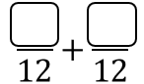
$$\frac{17x}{30}+\frac{x}{10}$$ | 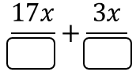
$$\frac{x}{6}+\frac{11x}{24}$$
$$\frac{3x}{4}-\frac{7x}{36}$$
$$\frac{7}{2x}+\frac{3}{x}$$ | 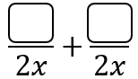
$$\frac{6}{5x}-\frac{9}{20x}$$
$$\frac{5}{x}+\frac{2}{x^{2}}$$ | 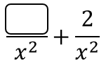
 | 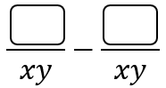 | $$\frac{3-y}{xy}$$
 | 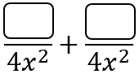 | $$\frac{7x+6}{{4x}^{2}}$$
$$\frac{3}{10xy}-\frac{2}{x^{2}}$$

