Venn Diagrams with Algebra
(a) | (b) | (c)
Some children are asked about whether they have any sisters or brothers. Six children said they had both sisters and brothers. Eight children said they had no sisters or brothers. Seven children said they had brothers but no sisters. $x$ children said they had sisters.  (i) Complete the Venn diagram, giving numbers in terms of $x$ where needed.  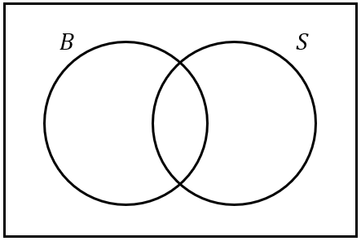  (ii) Given that there are 30 children in total, find the value of $x$ using algebra. | Some students are asked whether they study French, German or Spanish. Four students study all three languages. Six study both French and German, and $x$ students study French and Spanish. No students study both German and Spanish but not French. 21 students study French. 15 students study Spanish. 18 students study German. All students must study at least one language.  (i) Complete the Venn diagram, giving numbers in terms of $x$ where needed.  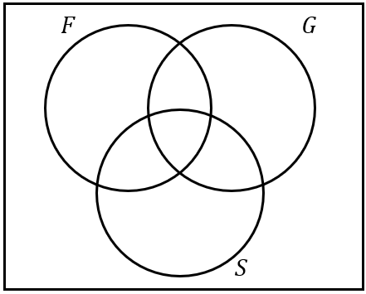  (ii) Given that there are 40 students in total, find the value of $x$ using algebra. | Some TV viewers are asked whether they enjoy drama, comedy or sport programmes. Six viewers enjoy none of them. $x$ viewers enjoy all three programmes. 15 viewers enjoy both drama and sport. 30 viewers enjoy both comedy and drama. 21 viewers enjoy both sport and comedy. 43 viewers enjoy comedy. 56 viewers enjoy sport. 38 viewers enjoy drama.  (i) Complete the Venn diagram, giving numbers in terms of $x$ where needed.  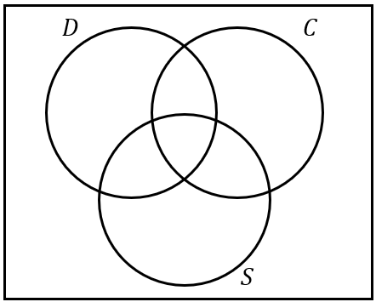  (ii) Given that there are 90 viewers in total, find the value of $x$ using algebra.

