Fill in the Blanks | Two-Step Functions

Input | Function Machine |  | Output | Function
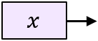 | 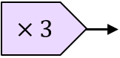 | 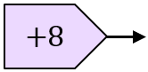 | 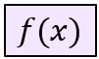 | $$f\left(x\right)=3x+8$$
 | 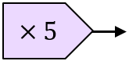 | 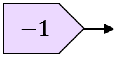
 | 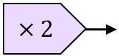 | 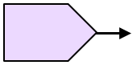 | 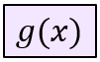 | $$g\left(x\right)=2x-7$$
 |  |  |  | $$f\left(x\right)=4(x-1)$$
 |  | 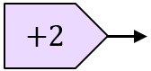 | 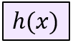 | $$h\left(x\right)=\frac{x}{3}+2$$
 | 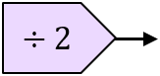 | 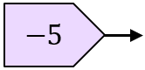
 | 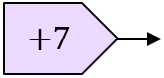 | 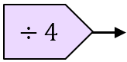
 | 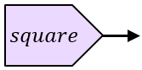 | 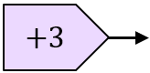
 |  | 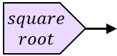
 |  |  |  | $$f\left(x\right)=10x^{2}$$
 |  |  |  | $$g\left(x\right)=\sqrt{x}+8$$
 |  |  |  | $$h\left(x\right)=\frac{x^{3}}{2}$$
 | 