Match-Up | Trigonometric Equations
Match the trigonometric equation with the correct diagram.
1 | 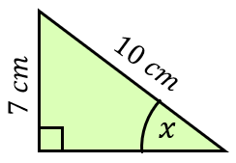 | 2 | 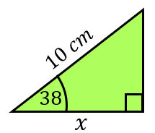 |  | A | $$x=\tan^{-1}\left(\frac{7}{10}\right)$$
 |  |  |  |  | B | $$x=10×\sin{38}$$
3 | 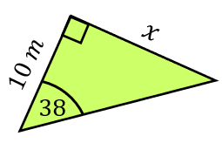 | 4 | 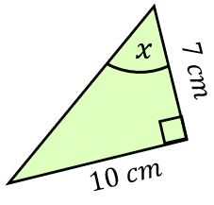 |  | C | $$x=10×\tan{38}$$
 |  |  |  |  | D | $$x=\frac{10}{\sin{38}}$$
5 | 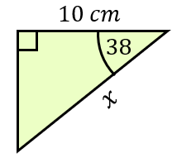 | 6 | 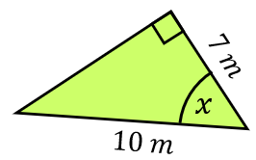 |  | E | $$x=\sin^{-1}\left(\frac{7}{10}\right)$$
 |  |  |  |  | F | $$x=\tan^{-1}\left(\frac{10}{7}\right)$$
7 | 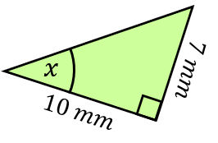 | 8 | 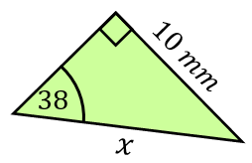 |  | G | $$x=10×\cos{38}$$
 |  |  |  |  | H | $$x=\frac{10}{\cos{38}}$$
9 | 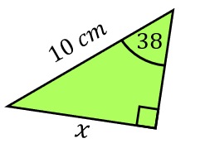 | 10 | 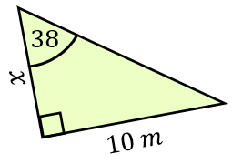 |  | I | $$x=\frac{10}{\tan{38}}$$
 |  |  |  |  | J | $$x=\cos^{-1}\left(\frac{7}{10}\right)$$

1 | 2 | 3 | 4 | 5 | 6 | 7 | 8 | 9 | 10

