Plotting Cubic Graphs
(a) | (b) | (c)
Plot the graph of $y=x^{3}+1$  from $x=-2$ to $x=2$ | Plot the graph of $y=x^{3}-2x^{2}-x+2$  from $x=-2$ to $x=3$ | Plot the graph of $y=3-x+2x^{2}-x^{3}$  from $x=-2$ to $x=3$
$$x$$ $$-2$$ $$-1$$ $$0$$ $$1$$ $$2$$  $$y$$ | $$x$$ $$-2$$ $$-1$$ $$0$$ $$1$$ $$2$$ $$3$$  $$y$$ | $$x$$ $$-2$$ $$-1$$ $$0$$ $$1$$ $$2$$ $$3$$  $$y$$
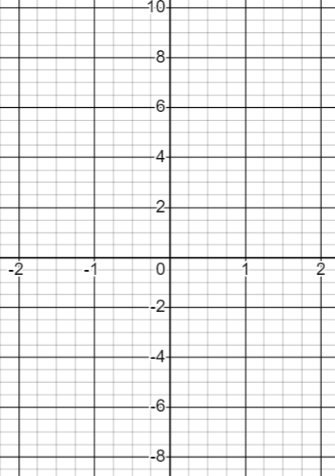 | 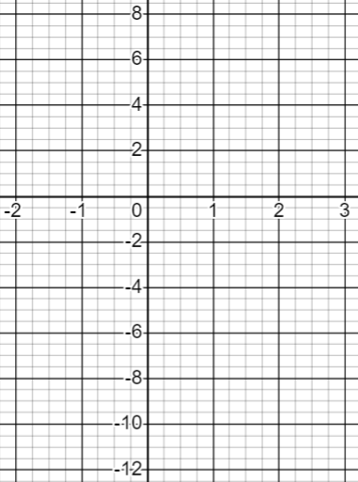 | 