Adding and Subtracting Vectors
(a) |  |  | (b) |  |  | (c)
The vectors $a$ and $b$ are shown. Draw the vector $a+b$.  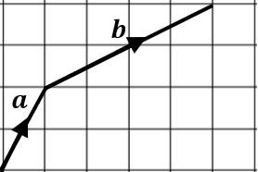 |  |  | The vectors $c$ and $-d$ are shown. Draw the vector $c+(-d)$.  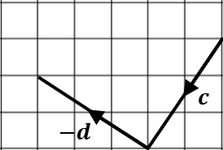 |  |  | 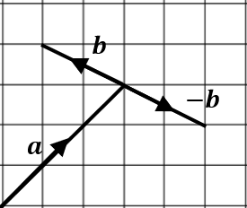 |  |  | The vectors $a, b$ and $-b$ are shown.  Draw the vectors  (i) $a+b$  (ii) $a+(-b)$.
(d) |  |  |  | (e) |  |  |  |  | (f)
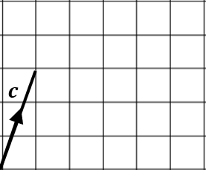 |  | $c=\left(\begin{matrix}1 \\ 3\end{matrix}\right)$ $d=\left(\begin{matrix}4 \\ -1\end{matrix}\right)$  Draw the vector  $c+d$ and find its column vector. |  | 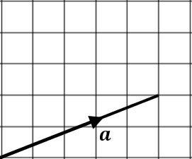 |  |  |  | $a=\left(\begin{matrix}5 \\ 2\end{matrix}\right)$ $b=\left(\begin{matrix}2 \\ 1\end{matrix}\right)$  Draw the vector $a-b$ and find its column vector. | $e=\left(\begin{matrix}7 \\ 1\end{matrix}\right)$ $f=\left(\begin{matrix}-3 \\ 4\end{matrix}\right)$  Find $e+f$
(g) | (h) |  |  |  | (i) |  | (j)
$c=\left(\begin{matrix}-2 \\ 5\end{matrix}\right)$ $d=\left(\begin{matrix}1 \\ 4\end{matrix}\right)$  Find $c-d$ | $$a=\left(\begin{matrix}0 \\ 4\end{matrix}\right) b=\left(\begin{matrix}6 \\ -3\end{matrix}\right)$$  Find $b-a$ |  |  |  | $e=\left(\begin{matrix}-6 \\ 1\end{matrix}\right)$ $f=\left(\begin{matrix}2 \\ -1\end{matrix}\right)$  Find $-e+f$ |  | $a=\left(\begin{matrix}8 \\ 0\end{matrix}\right)$ $b=\left(\begin{matrix}-2 \\ -5\end{matrix}\right) c=\left(\begin{matrix}-3 \\ 7\end{matrix}\right)$  Find (i) $a+b+c$ (ii) $a+b-c$ (iii) $a-b-c$

