Plotting Line Graphs
(a) | (b)
The table shows the maximum and monthly minimum temperatures in $℃$ in Manchester over a year.  Month J F M A M J J A S O N D  Minimum 2 1 2 4 7 10 12 12 10 8 4 2  Maximum 6 7 9 12 15 17 19 19 17 13 9 7 | The table shows the number of rainy days per month in Bolton and London over a year.  Month J F M A M J J A S O N D  Bolton 14 10 13 12 10 11 11 12 11 14 14 13  London 12 9 10 9 9 8 8 8 9 11 10 10
Draw a line graph to represent this information. Include a key.  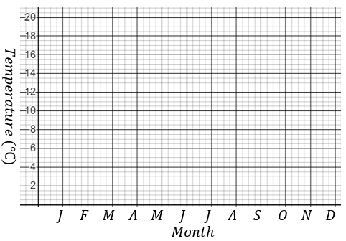 | Draw a line graph to represent this information. Include a key.  