Statistics and Probability Revision |  |  |  | 5
(a) |  | (b)
When a drawing pin is thrown, it can land point up or point down. The probability that the drawing pin lands point up is 0.7. Maya throws the drawing pin twice. |  | The table gives information about the birth weights of 80 piglets.  (i) Complete a cumulative frequency graph.
 |  | Weight $w$ (kg) Cumulative frequency  $$0≤w<0.2$$ $$8$$  $$0≤w<0.4$$ $$17$$  $$0≤w<0.6$$ $$33$$  $$0≤w<0.8$$ $$58$$  $$0≤w<1$$ $$74$$  $$0≤w<1.2$$ $$80$$ | 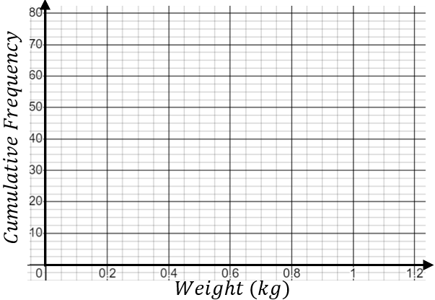
(i) Complete the tree diagram.  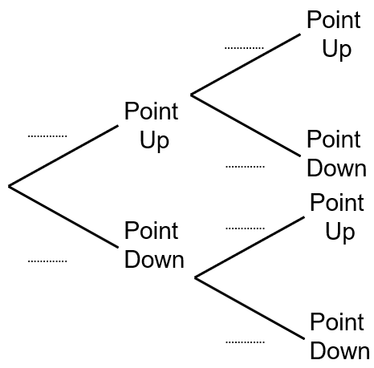 | (ii) Work out the probability that the drawing pin lands point up both times.  (iii) Work out the probability that the drawing pin lands point up exactly once.
 |  | (ii) Use the graph to estimate the median and interquartile range of the weights of the piglets.
(c) |  | (d)
Here is a list of ages of the fifteen students in a school library on a Monday lunchtime.  $$12 9 15 16 10 9 11 10 9 13 15 10 8 17 15$$  (i) Find the median age.  (ii) Find the interquartile range of the ages. |  | Complete the histogram for the information in the table.
 |  | Height $h$(cm) Frequency  $$10≤h<30$$ $$8$$  $$30≤h<40$$ $$18$$  $$40≤h<50$$ $$24$$  $$50≤h<60$$ $$20$$  $$60≤h<100$$ $$12$$ | 