Puzzle |  |  | Prime Factors
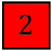 |  | 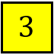 |  |  |  |  |  |  |  | 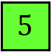 |  |  |  |  | 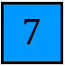 |  |  | 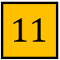 |  | 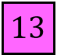
Using the prime factor tiles above, fill in each of the gaps.
 |  |  |  |  | A prime number |  |  |  |  |  |  |  |  |  |  |  | A factor of 90
 |  |  |  |  | A prime factor of 30 |  |  |  |  |  |  |  |  |  |  |  | A triangular number
 |  |  |  |  | A square number |  |  |  |  |  |  |  |  |  |  |  | A cube number
 |  |  |  |  | A multiple of 7 |  |  |  |  |  |  |  |  |  |  |  | A multiple of 10
Can you find more than one set of possible answers?

