Constructing a Knot from a Seed of Life
For this construction you will need to work on a piece of A4 paper in portrait.
Step 1 – Start with a seed of life made up of seven circles of radius 4 cm.  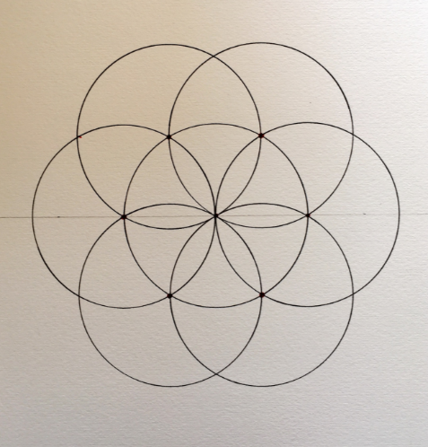 | Step 2 – Set compasses to a radius of 3 cm and with compass point on red intersection point, draw in an arc.  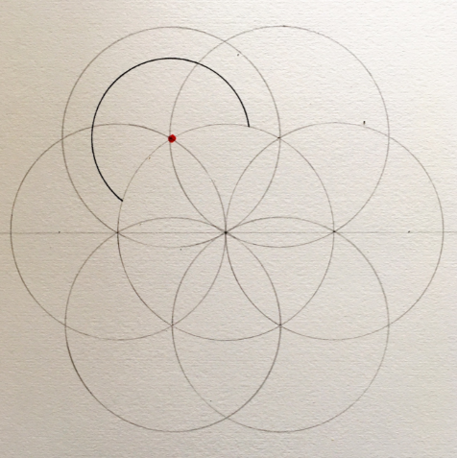 | Step 3 – Keeping compasses at same radius, add arcs from each of the red intersection points.  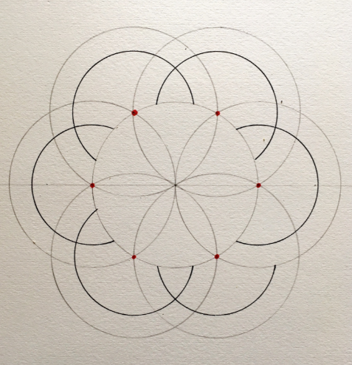
Step 4 – With compass point on the blue intersection point, open to point A and draw in arc shown.  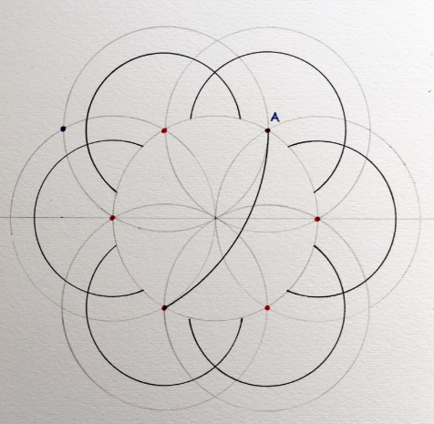 | Step 5 – Keeping compasses at same radius, add arcs from each of the blue intersection points.  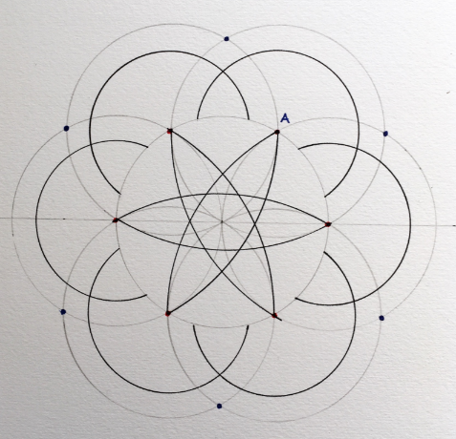 | Step 6 – Using the same intersection point as step 4, open up the compasses to point B and draw an arc. Repeat from all intersection points.  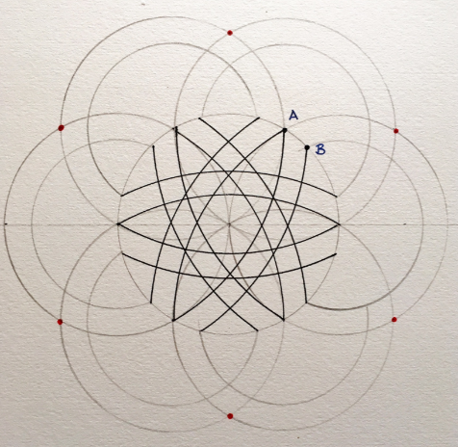
Step 7 – Outline the knot in pen as shown, either by hand or using a pen in your compasses.  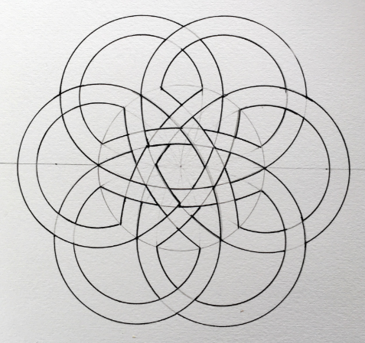 | Step 8 - Colour in your knot using pencils or fineliners!  