Measuring Time

Write down the times shown. Give them in both 12-hour (am/pm) and 24-hour clock format.
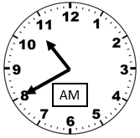
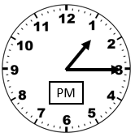
(a) (b)

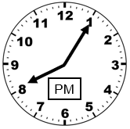
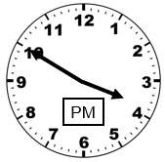
(c) (d)

(a) An overnight train sets off at 10 pm and arrives at 5.30 am. How long, in hours and minutes, is the journey?
(b) A TV programme starts at 5.35 pm and finishes at 7.12 pm. How long, in minutes, is the programme?
(c) A factory worker starts his shift at 8.12 am and finishes it at 4.43pm. How long, in hours and minutes, is his shift?

(a) Younis starts watching a film at 5.45 pm. The film lasts 2 hours 27 minutes. What time does the film finish?
(b) A plane takes off at 3.40 am. The length of the flight is 10 hours 45 minutes. What time does the plane land?
(c) A concert lasts 3 hours 27 minutes. The concert finishes at 9.58 pm. What time did the concert start?

(a) What time is 1500 seconds after 16:10?
(b) What time is 2100 seconds before 15:45?
Measuring Time

Write down the times shown. Give them in both 12-hour (am/pm) and 24-hour clock format.
(a) (b)

(c) (d)

(a) An overnight train sets off at 10 pm and arrives at 5.30 am. How long, in hours and minutes, is the journey?
(b) A TV programme starts at 5.35 pm and finishes at 7.12 pm. How long, in minutes, is the programme?
(c) A factory worker starts his shift at 8.12 am and finishes it at 4.43pm. How long, in hours and minutes, is his shift?

(a) Younis starts watching a film at 5.45 pm. The film lasts 2 hours 27 minutes. What time does the film finish?
(b) A plane takes off at 3.40 am. The length of the flight is 10 hours 45 minutes. What time does the plane land?
(c) A concert lasts 3 hours 27 minutes. The concert finishes at 9.58 pm. What time did the concert start?

(a) What time is 1500 seconds after 16:10?
(b) What time is 2100 seconds before 15:45?

