Match-Up | Transformations of Trigonometric Graphs

1 | 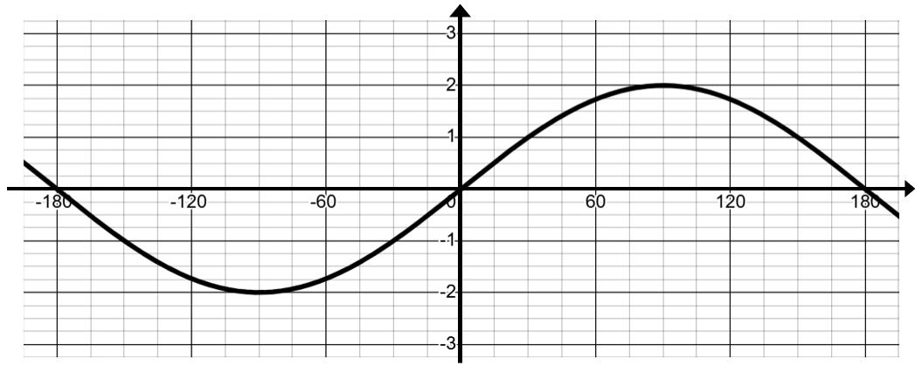 |  | 7 | 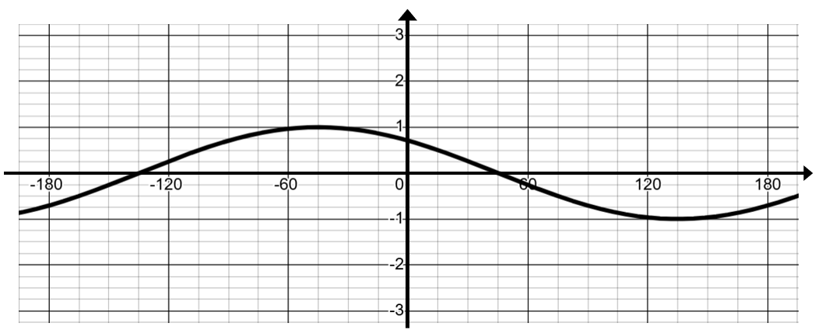
2 | 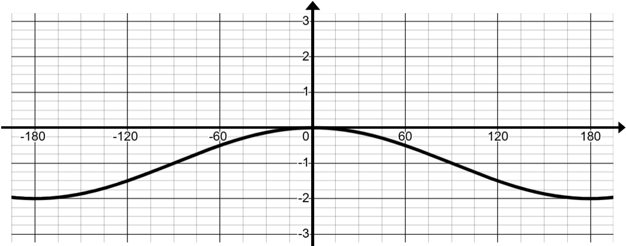 |  | 8 | 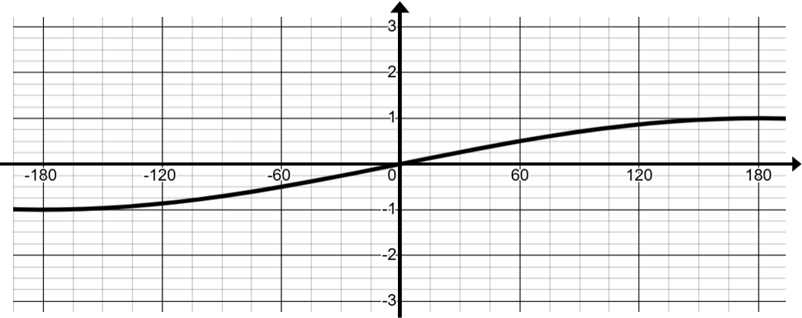
3 | 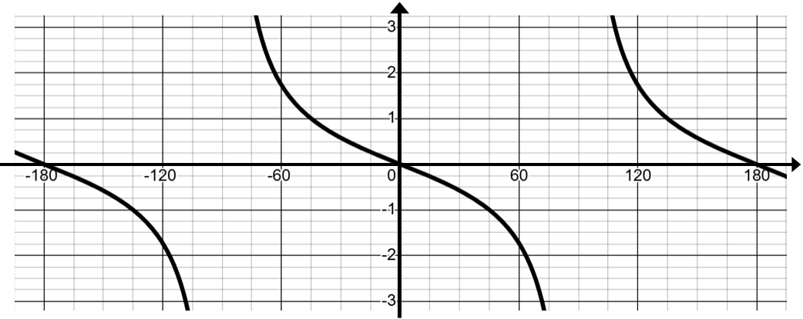 |  | 9 | 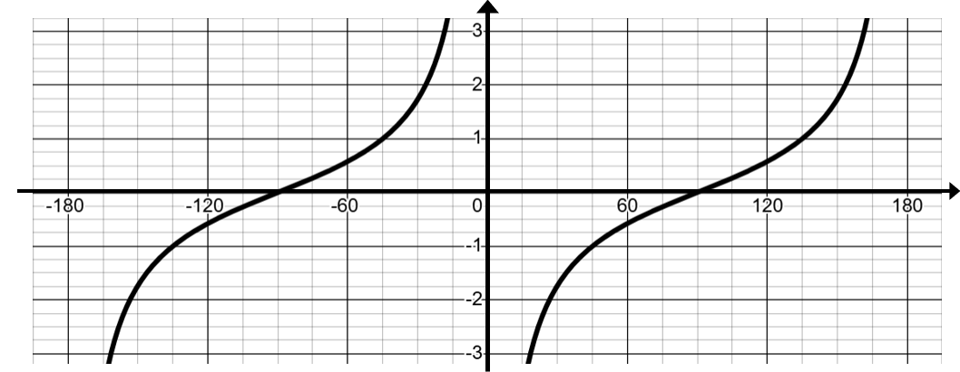
4 | 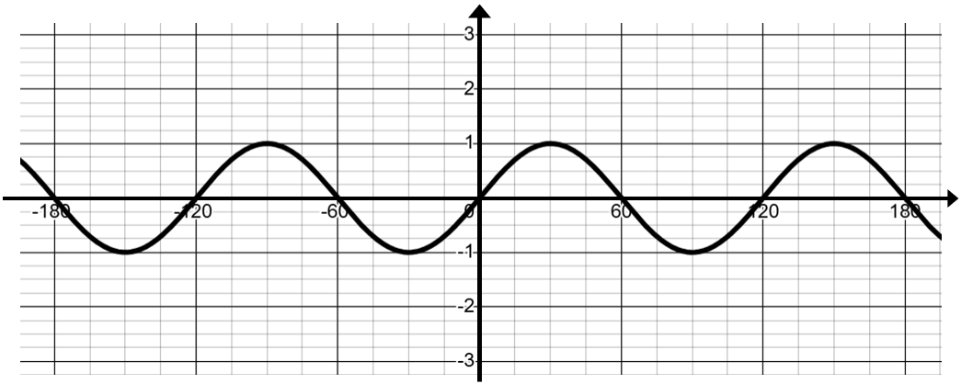 |  | 10 | 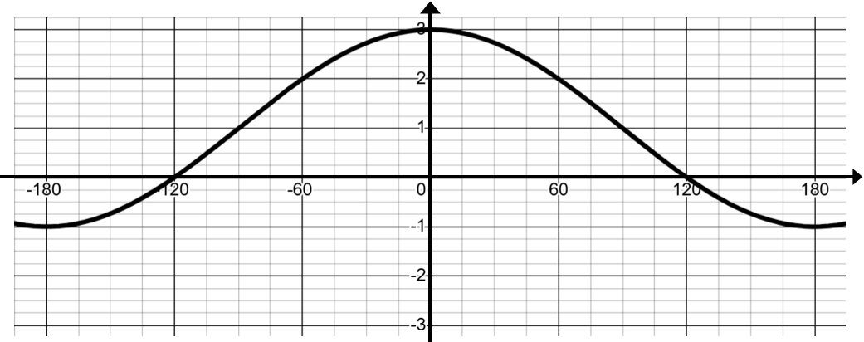
5 | 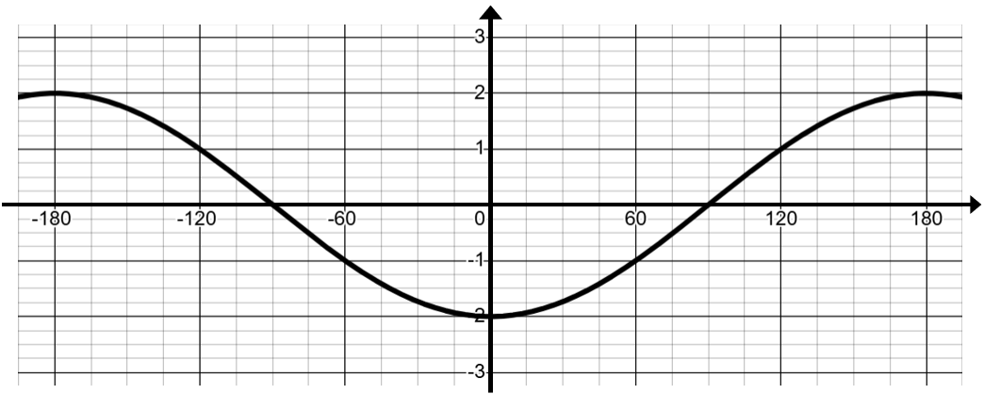 |  | 11 | 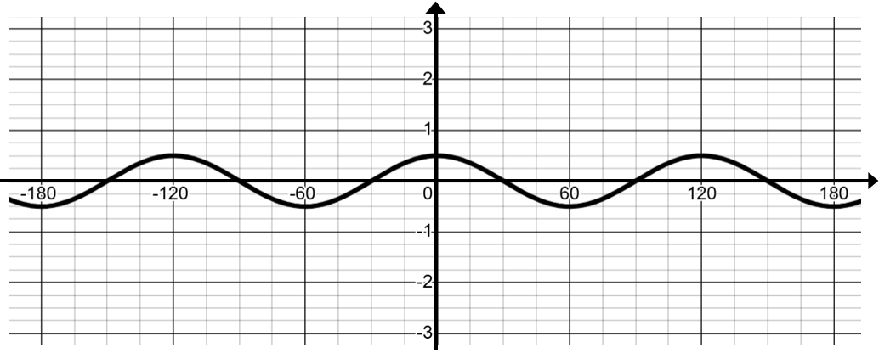
6 | 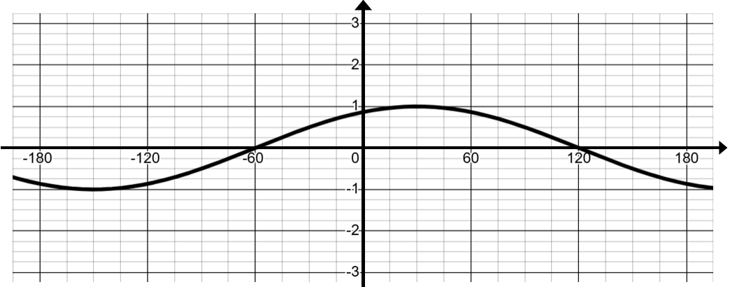 |  | 12 | 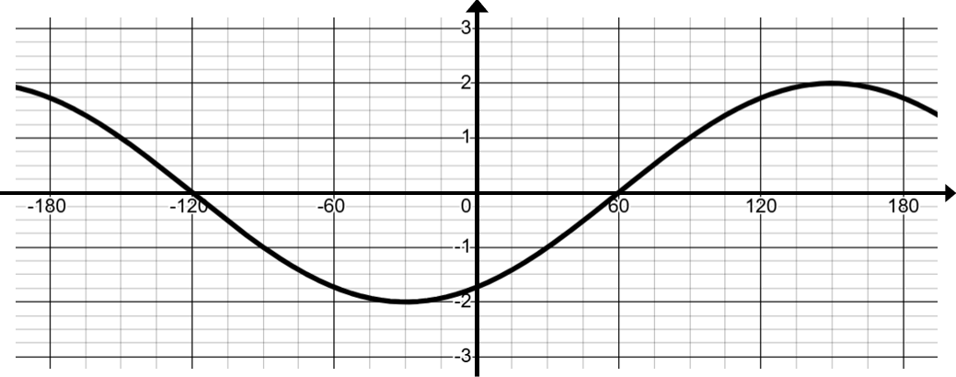

A | $$y=\sin{(3x)}$$ | E | $$y=2 sin{(x-60°)}$$ | I | $$y=\cos\left(x\right)-1$$
B | $$y=2\cos\left(x\right)+1$$ | F | $$y=\tan{(x-90°})$$ | J | $$y=\sin{(x+60°)}$$
C | $$y=-2\cos{(x)}$$ | G | $$y=2\sin{(x)}$$ | K | $$y=\sin\left(\frac{x}{2}\right)$$
D | $$y=\frac{1}{2}\cos{(3x)}$$ | H | $$y=\cos{(x+45°)}$$ | L | $$y=-\tan{(x)}$$

1 | 2 | 3 | 4 | 5 | 6 | 7 | 8 | 9 | 10 | 11 | 12

