Circle Theorems Revision
(a) | (b) | (c) | (d)
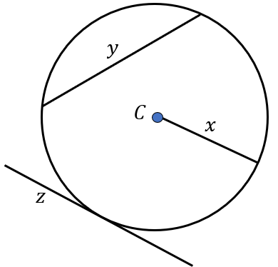  Write down the names of lines $x, y$ and $z$. | Find the size of angle AOB.  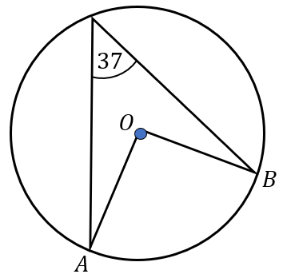 | Find the size of angle ABC.  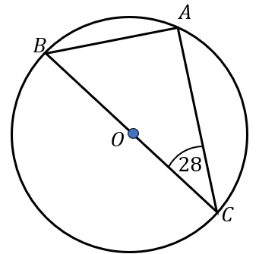 | 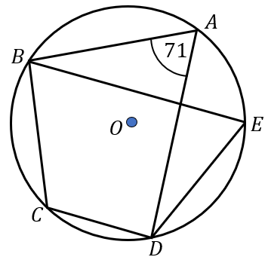  Find the size of angles BED and BCD.
(e) | (f) | (g) | (h)
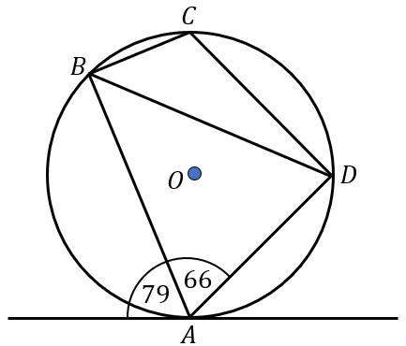  Find the size of angles ADB and BCD. | 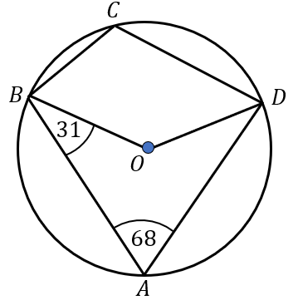  Find the size of angles BOD and ADO. | AB and BC are tangents. Find the size of angle ADC.  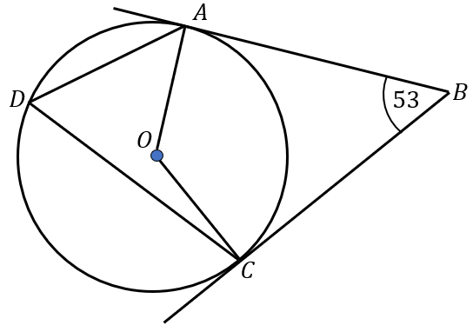 | Find the length of AC.  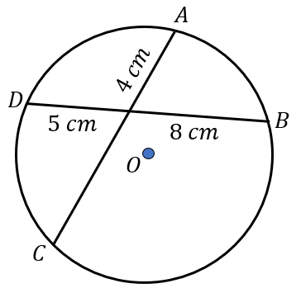
(i) | (j) | (k) | (l)
Find the size of angle BAC.  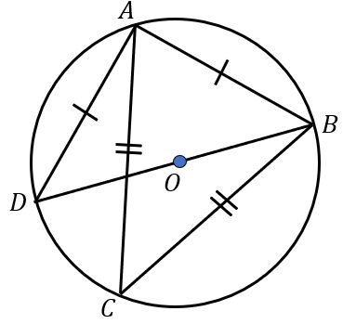 | 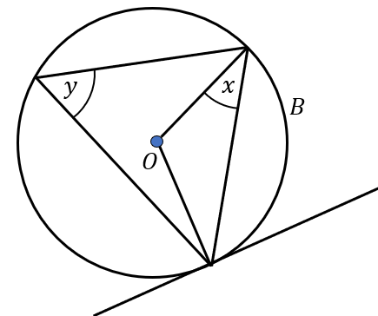  Find an expression for $y$ in terms of $x$ | Find the value of $x$, giving your answer as a simplified surd.  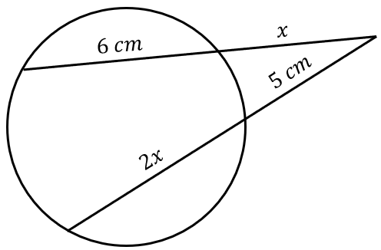 | Find the value of $x$.  