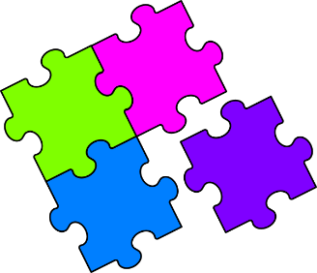
Match-Up
Converting Units of Area and Volume

1 | $$4 {cm}^{2}$$ |  | 6 | $$45.4 m^{2}$$ |  | 11 | $$4000 litres$$
2 | $$0.04 m^{3}$$ |  | 7 | $$45 litres$$ |  | 12 | $$0.00454 m^{3}$$
3 | $$4000 {mm}^{2}$$ |  | 8 | $$0.454 m^{2}$$ |  | 13 | $$0.45 m^{2}$$
4 | $$450000 {mm}^{3}$$ |  | 9 | $$4540 {mm}^{3}$$ |  | 14 | $$45 {cm}^{3}$$
5 | $$4000 {cm}^{3}$$ |  | 10 | $$4.5 {cm}^{2}$$ |  | 15 | $$400000 {cm}^{3}$$
A | $$0.4 m^{3}$$ |  | F | $$4540 {cm}^{3}$$ |  | K | $$0.045 litres$$
B | $$45000 {cm}^{3}$$ |  | G | $$40 {cm}^{2}$$ |  | L | $$40000 {cm}^{3}$$
C | $$454000 {cm}^{2}$$ |  | H | $$400 {mm}^{2}$$ |  | M | $$450 {mm}^{2}$$
D | $$4 litres$$ |  | I | $$450000 {mm}^{2}$$ |  | N | $$454000 {mm}^{2}$$
E | $$4.54 {cm}^{3}$$ |  | J | $$450 {cm}^{3}$$ |  | P | $$4000000 {cm}^{3}$$

1 | 2 | 3 | 4 | 5 | 6 | 7 | 8 | 9 | 10 | 11 | 12 | 13 | 14 | 15

