Compound Shapes

Find the area and perimeter of these compound shapes.
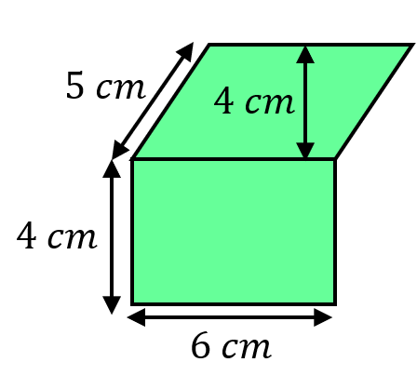
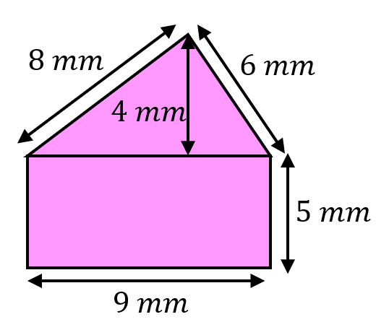
(a) (b)

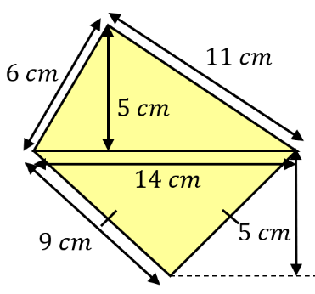
(c)

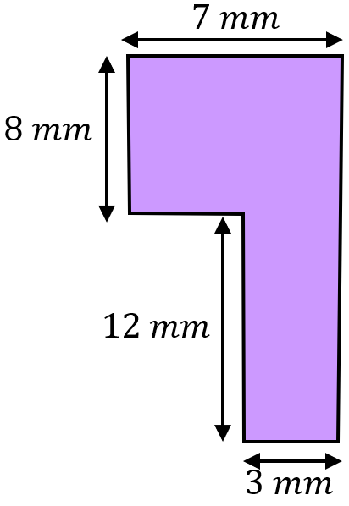
Find the area and perimeter of these compound shapes.
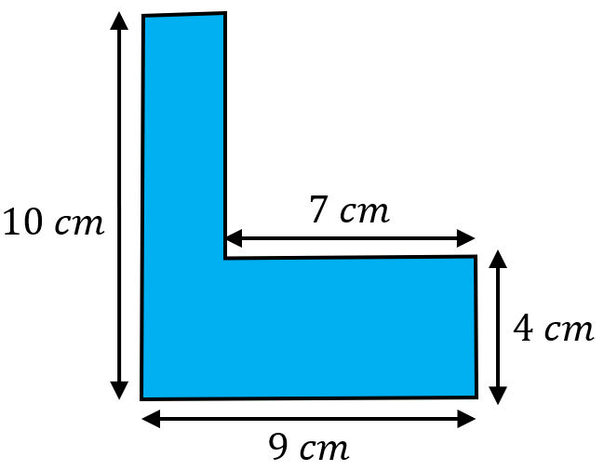
(a) (b)

Find the area of the shaded shapes.
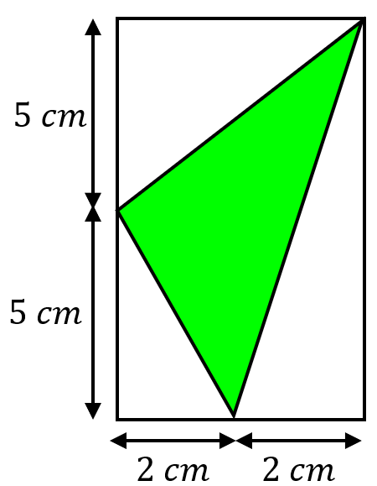
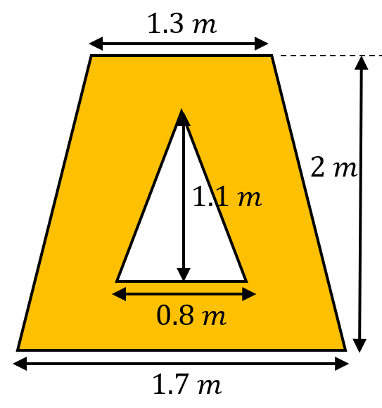
(a) (b)

Compound Shapes

Find the area and perimeter of these compound shapes.
(a) (b)

(c)

Find the area and perimeter of these compound shapes.
(a) (b)

Find the area of the shaded shapes.
(a) (b)

