Algebra Revision |  |  |  | 3
(a) | (b) | (c) | (d)
An apple costs 20p and a banana costs 25p. Write a formula for the total cost $C$ of $x$ apples and $y$ bananas. | Solve $4x+y=13$  $2x-3y=17$ | Expand and simplify  $$(2x-1)(3x+5)$$ | (i) Factorise  $$x^{2}+2x-35$$  (ii) Hence solve  $$x^{2}+2x-35=0$$
(e) |  | (f)
Plot the graph of $y=5-2x$  $$x$$ $$-2$$ $$-1$$ $$0$$ $$1$$ $$2$$  $$y$$  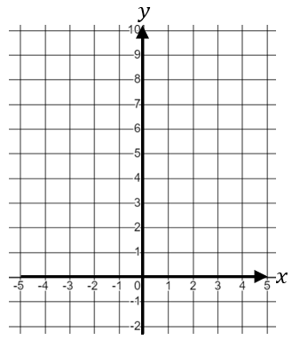 |  | Plot the graph of  $$y=x^{2}-2x-3$$  $$x$$ $$-2$$ $$-1$$ $$0$$ $$1$$ $$2$$ $$3$$ $$4$$  $$y$$  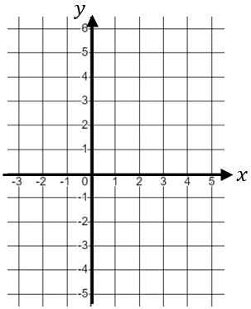
 |  |  | (h)
Use the graph to convert 50 euros into Japanese Yen

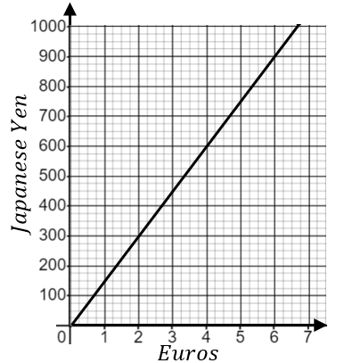
 | (g)
Solve
$$-5<2x+3≤4$$
 | (i)
 | Find the y-intercept of the straight line with equation $2y-5x=6$

