Listing Outcomes and Sample Spaces

At a café, children can choose from either fish fingers, chicken nuggets or pizza for their main course, and ice cream, fruit or jelly for their dessert. List all the possible combinations of meals. What is the probability that a child chooses chicken nuggets followed by jelly?

A door code is made up of three digits. The first digit can be 1, 2 or 3. The second digit can be 4 or 5, and the third digit can be 6 or 7. List all the possible door codes. What is the probability that the three-digit door code is a multiple of three?

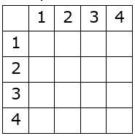
Lucy has two four-sided fair spinners, each number 1 to 4. She spins both spinners, the add their scores together.

(a) Complete the sample space.
(b) What is the probability of the total being a multiple of 3?
(c) What is the probability of the total being greater than 5?

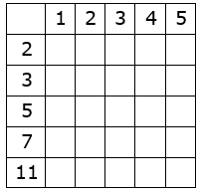
Tariq has two five-sided fair spinners. The first spinner is numbered 1, 2, 3, 4 and 5 and the second spinner is numbered 2, 3, 5, 7 and 11. He spins each spinner once and finds the difference between their scores.
(a) Complete the sample space.
(b) Find the probability that the difference between the scores is zero.
(c) Find the probability that the difference between the scores is greater than four.

Listing Outcomes and Sample Spaces

At a café, children can choose from either fish fingers, chicken nuggets or pizza for their main course, and ice cream, fruit or jelly for their dessert. List all the possible combinations of meals. What is the probability that a child chooses chicken nuggets followed by jelly?

A door code is made up of three digits. The first digit can be 1, 2 or 3. The second digit can be 4 or 5, and the third digit can be 6 or 7. List all the possible door codes. What is the probability that the three-digit door code is a multiple of three?

Lucy has two four-sided fair spinners, each number 1 to 4. She spins both spinners, the add their scores together.

(a) Complete the sample space.
(b) What is the probability of the total being a multiple of 3?
(c) What is the probability of the total being greater than 5?

Tariq has two five-sided fair spinners. The first spinner is numbered 1, 2, 3, 4 and 5 and the second spinner is numbered 2, 3, 5, 7 and 11. He spins each spinner once and finds the difference between their scores.
(a) Complete the sample space.
(b) Find the probability that the difference between the scores is zero.
(c) Find the probability that the difference between the scores is greater than four.

