Solving Harder Quadratic Equations in Context
(a) | (b)
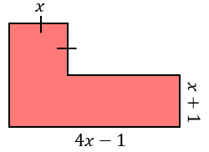  The shape shown has an area of $13 {cm}^{2}$. All lengths on the diagram are in cm.  (i) Show that $5x^{2}+3x-14=0$  (ii) Hence, find the value of $x$ and the dimensions of the shape. | 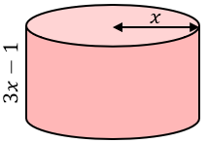  The cylinder shown has a total surface area of $78π {cm}^{2}$. All lengths on the diagram are in centimetres.  (i) Show that $4x^{2}-x-39=0$  (ii) Hence, find the value of $x$ and the height of the cylinder.
(c) | (d)
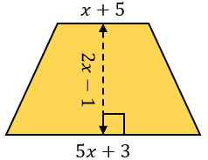  The trapezium shown has an area of $30 {cm}^{2}$. All lengths on the diagram are in centimetres.  (i) Show that $6x^{2}+5x-34=0$  (ii) Hence, find the value of $x$ and the dimensions of the trapezium. | 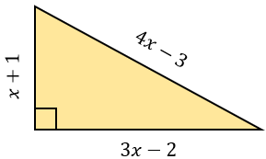  A right-angled triangle has sides of lengths $\left(x+1\right) cm, \left(3x-2\right) cm$and $\left(4x-3\right) cm$ as shown.  (i) Show that $3x^{2}-7x+2=0$  (ii) Hence find the value of $x$ and the length of the hypotenuse.

