Crack the Code | Matrix Multiplication

A | 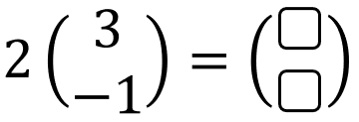 | B | 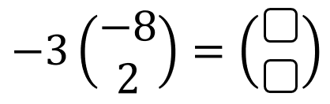
C | 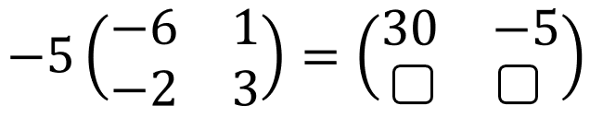 | D | 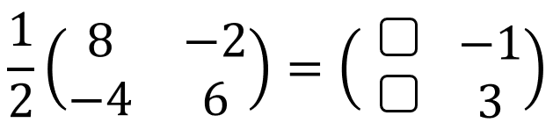
E | 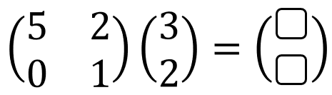 | F | 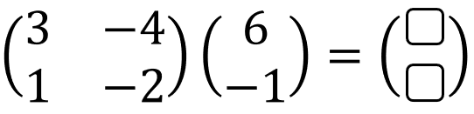
G | 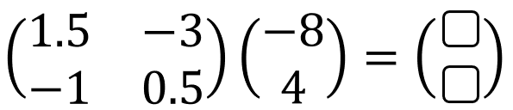 | H | 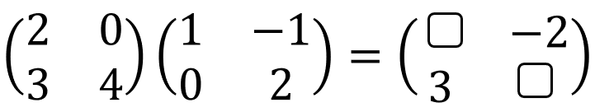
I | 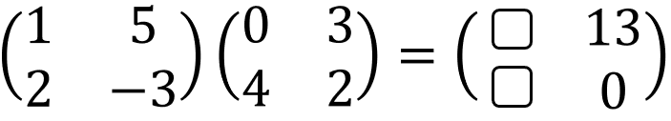 | J | 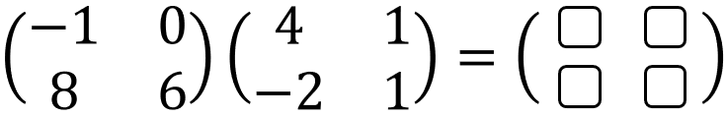
K | 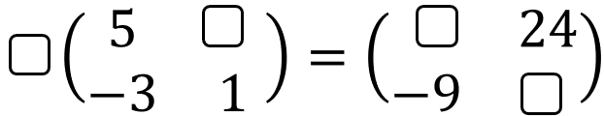 | L | 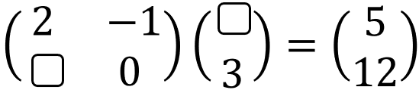
M | 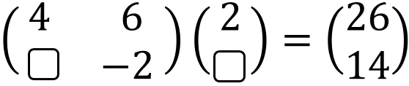 | N | 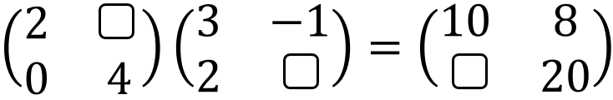
O | 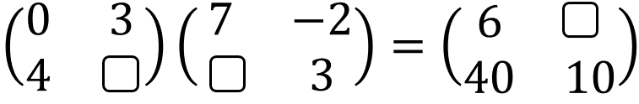 | P | 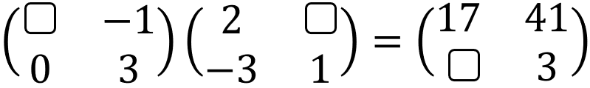
To get the three-digit code, add together all your answers.

