Volume and Surface Area of Compound Shapes
(a) | (b)
Find the volume and surface area of the 3D shape shown.  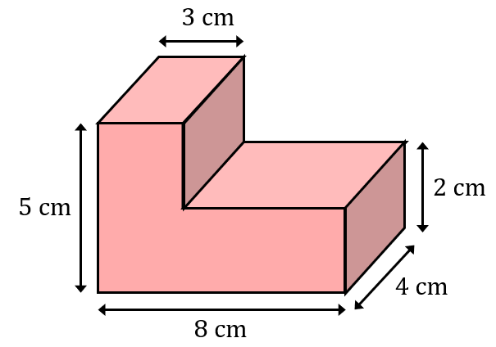 | Find the volume and surface area of the 3D shape shown.  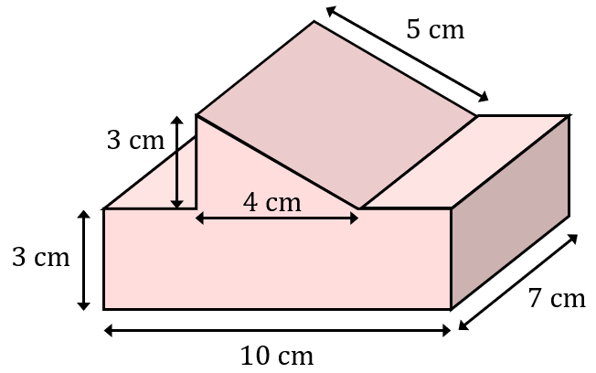
(c) | (d)
A compound shape is made up of two cuboids. Find the volume and surface area of the compound shape.  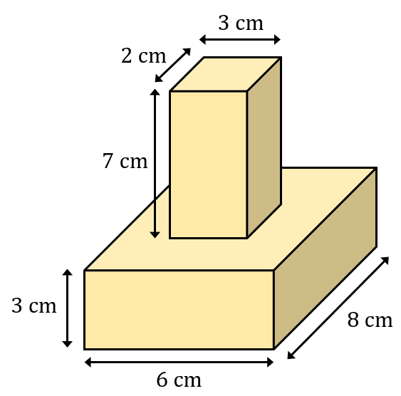 | A compound shape is made up of a cube and a trapezoidal prism. The total volume of the shape is $1504 {cm}^{3}.$ Find the side length of the cube and the surface area of the compound shape.  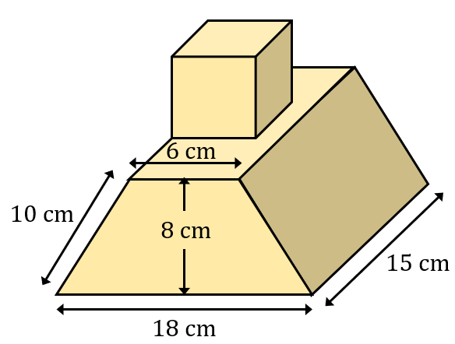
(e) | (f)
A 3D shape is made by cutting a cuboid out of another cuboid. Find the volume and surface area of the resulting shape.  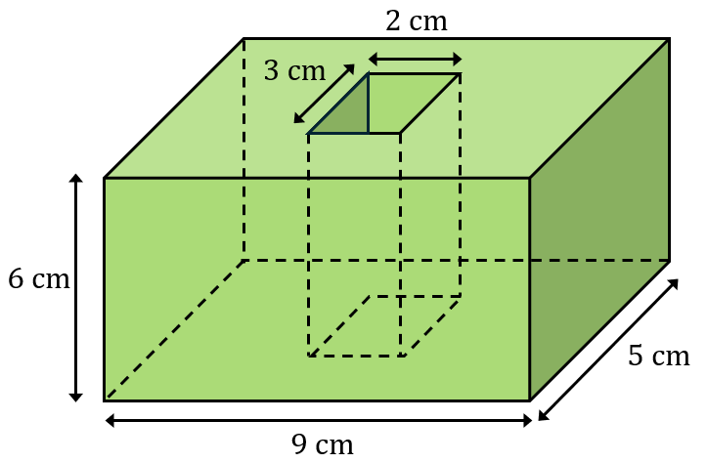 | A triangular prism is cut from a cube. The triangular prism has a cross section which is an equilateral triangle of side length 5 cm. Find the volume and surface area of the resulting shape.  