Puzzle | Pythagoras Pile Up
Find (a) the value of $x$, (b) the perimeter of the compound shape and (c) the area of the compound shape. Give all your answers to $3$ significant figures.
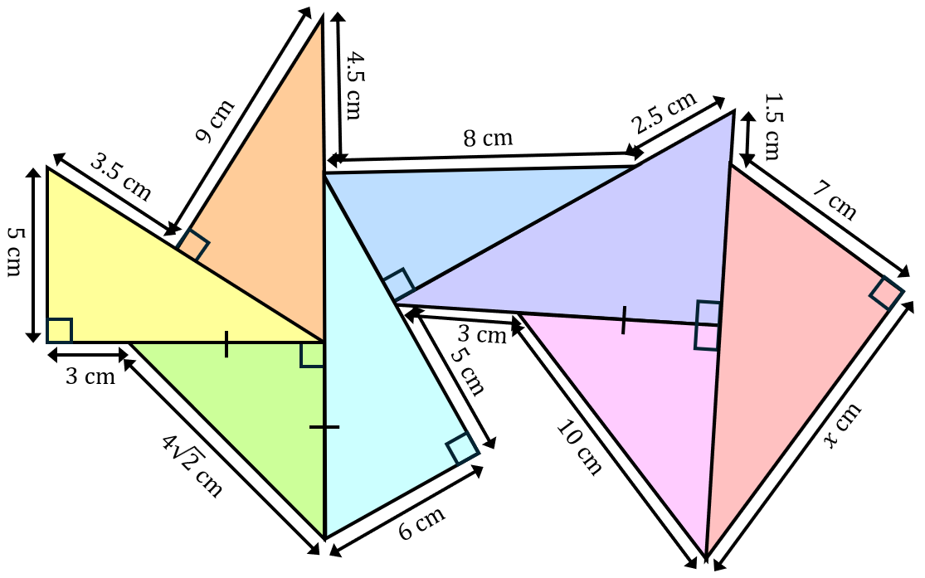

Puzzle | Pythagoras Pile Up
Find (a) the value of $x$, (b) the perimeter of the compound shape and (c) the area of the compound shape. Give all your answers to $3$ significant figures.

