Sketching Reciprocal Graphs
(a) | (b) | (c)
Sketch the graph of $y=\frac{1}{x^{2}}$ stating the equations of any asymptotes. | Sketch the graph of $y=-\frac{2}{x}$ stating the equations of any asymptotes. | On the same axes, sketch the graphs of  $y=\frac{3}{x}$ and $y=\frac{9}{x}$
(d) | (e) | (f)
Find the equation of the graph shown.  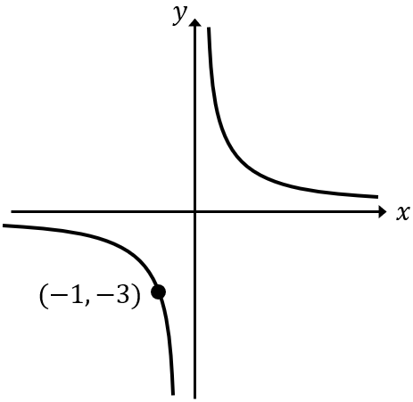 | Find the equation of the graph shown.  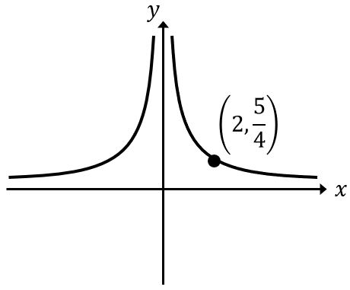 | Find the equation of the graph shown.  