Fill In The Blanks…
Arc Length and Perimeter of a Sector
Radius | Angle | Arc Length | Perimeter
$$8 cm$$ | $$90°$$ | $$\frac{90}{360}×π×2×8=12.6 cm$$ | $$28.6 cm$$
$$7 cm$$ | $$45°$$ | $$\frac{45}{360}×π×2×7=5.5 cm$$
$$15 mm$$ | $$60°$$ | $$\frac{60}{360}×π×2×15=15.7 mm$$
$$4 cm$$ | $$75°$$
$$1.8 m$$ | $$130°$$
$$11 cm$$ | $$275°$$
$$9 mm$$ | $$32°$$
$$10 cm$$ |  | 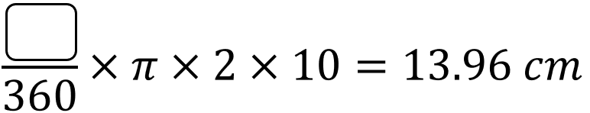
$$25 mm$$ |  | 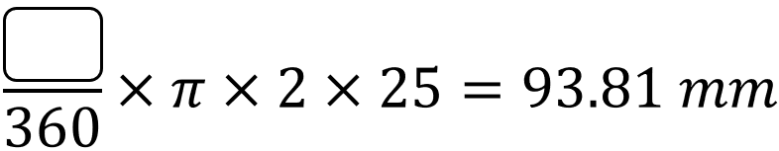
$$2 m$$ |  | 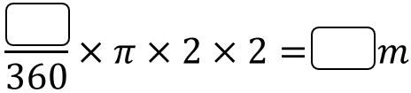 | $$5.05 m$$
$$8.9 cm$$ |  | 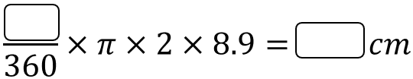 | $$35.2 m$$
 |  | 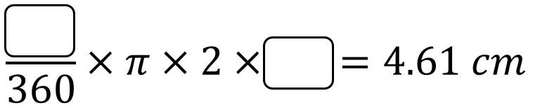 | $$15.61 cm$$
 |  | 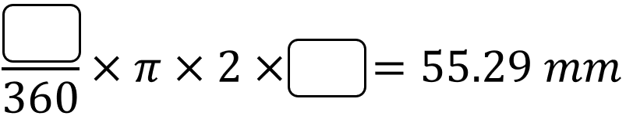 | $$99.29 mm$$

